Table of Contents

UNITED STATES

SECURITIES AND EXCHANGE COMMISSION
WASHINGTON, D.C. 20549

FORM 10-Q

(Mark One)

- QUARTERLY REPORT PURSUANT TO SECTION 13 OR 15(d) OF THE SECURITIES EXCHANGE ACT OF 1934

For the quarterly period ended March 31, 2026

OR

- TRANSITION REPORT PURSUANT TO SECTION 13 OR 15(d) OF THE SECURITIES EXCHANGE ACT OF 1934

 |  |  | For the transition period from |  |  | to
 |  |  |  |  | Commission File Number 000-23125
 |  |  |  | OSI SYSTEMS, INC.
 |  |  | (Exact name of registrant as specified in its charter)
 | Delaware |  |  |  | ​​​ |  |  |  |  | 33-0238801
 | (State or other jurisdiction of |  |  |  |  |  |  |  |  | (I.R.S. Employer
 | incorporation or organization) |  |  |  |  |  |  |  |  | Identification No.)
 |  |  |  |  | 12525 Chadron Avenue
 |  |  |  |  | Hawthorne, California 90250
 |  | (Address of principal executive offices) (Zip Code)
 |  |  |  |  | (310) 978-0516
 |  | (Registrant’s telephone number, including area code)
 |  |  |  |  | N/A
 | (Former name, former address and former fiscal year, if changed since last report)
Securities registered pursuant to Section 12(b) of the Act:
 | Title of each class |  |  | ​​​ | Trading Symbol(s) |  | ​​​ |  |  | Name of each exchange on which registered
 | Common Stock, $0.001 par value |  |  |  | OSIS |  |  |  |  | The Nasdaq Global Select Market


Indicate by check mark whether the registrant (1) has filed all reports required to be filed by Section 13 or 15(d) of the Securities Exchange Act of 1934 during the preceding 12 months (or for such shorter period that the registrant was required to file such reports), and (2) has been subject to such filing requirements for the past 90 days. Yes ☒ No ☐

Indicate by check mark whether the registrant has submitted electronically every Interactive Data File required to be submitted pursuant to Rule 405 of Regulation S-T (§232.405 of this chapter) during the preceding 12 months (or for such shorter period that the registrant was required to submit such files). Yes ☒ No ☐

Indicate by check mark whether the registrant is a large accelerated filer, an accelerated filer, a non-accelerated filer, a smaller reporting company, or an emerging growth company.

See the definitions of “large accelerated filer,” “accelerated filer,” “smaller reporting company,” and “emerging growth company” in Rule 12b-2 of the Exchange Act.

Large accelerated filer ☒

​​

Accelerated filer ☐

Non-accelerated filer ☐

Smaller reporting company ☐

Emerging growth company ☐

If an emerging growth company, indicate by check mark if the registrant has elected not to use the extended transition period for complying with any new or revised financial accounting standards provided pursuant to Section 13(a) of the Exchange Act. ☐

Indicate by check mark whether the registrant is a shell company (as defined in Rule 12b-2 of the Exchange Act). Yes ☐ No ☒ As of April 28, 2026, there were 16,482,890 shares of the registrant’s common stock outstanding.

Table of Contents

OSI SYSTEMS, INC.

INDEX

 |  |  |  |  |  |  |  |  |  |  |  |  |  |  |  |  |  |  |  |  |  |  |  | PAGE
PART I — FINANCIAL INFORMATION |  |  |  |  |  |  |  |  |  |  |  |  |  |  |  |  |  |  |  |  |  |  |  | 3
 | Item 1 — |  |  |  |  | Financial Statements (Unaudited) |  |  |  |  |  |  |  |  |  |  |  |  |  |  |  |  |  | 3
 |  |  |  |  |  | Condensed Consolidated Balance Sheets at June 30, 2025 and March 31, 2026 |  |  |  |  |  |  |  |  |  |  |  |  |  |  |  |  |  | 3
 |  |  |  |  |  | Condensed Consolidated Statements of Operations for the three and nine months ended March 31, 2025 and 2026 |  |  |  |  |  |  |  |  |  |  |  |  |  |  |  |  |  | 4
 |  |  |  |  |  | Condensed Consolidated Statements of Comprehensive Income for the three and nine months ended March 31, 2025 and
 |  |  |  |  |  | 2026 |  |  |  |  |  |  |  |  |  |  |  |  |  |  |  |  |  | 5
 |  |  |  |  |  | Condensed Consolidated Statements of Stockholders’ Equity for the three and nine months ended March 31, 2025 and 2026 |  |  |  |  |  |  |  |  |  |  |  |  |  |  |  |  |  | 6
 |  |  |  |  |  | Condensed Consolidated Statements of Cash Flows for the nine months ended March 31, 2025 and 2026 |  |  |  |  |  |  |  |  |  |  |  |  |  |  |  |  |  | 8
 |  |  |  |  |  | Notes to Condensed Consolidated Financial Statements |  |  |  |  |  |  |  |  |  |  |  |  |  |  |  |  |  | 9
 | Item 2 — |  |  |  |  | Management’s Discussion and Analysis of Financial Condition and Results of Operations |  |  |  |  |  |  |  |  |  |  |  |  |  |  |  |  |  | 28
 | Item 3 — |  |  |  |  | Quantitative and Qualitative Disclosures about Market Risk |  |  |  |  |  |  |  |  |  |  |  |  |  |  |  |  |  | 35
 | Item 4 — |  |  |  |  | Controls and Procedures |  |  |  |  |  |  |  |  |  |  |  |  |  |  |  |  |  | 35
PART II — OTHER INFORMATION |  |  |  |  |  |  |  |  |  |  |  |  |  |  |  |  |  |  |  |  |  |  |  | 36
 | Item 1 — |  |  |  |  | Legal Proceedings |  |  |  |  |  |  |  |  |  |  |  |  |  |  |  |  |  | 36
 | Item 1A — |  |  |  |  | Risk Factors |  |  |  |  |  |  |  |  |  |  |  |  |  |  |  |  |  | 36
 | Item 2 — |  |  |  |  | Unregistered Sales of Equity Securities and Use of Proceeds |  |  |  |  |  |  |  |  |  |  |  |  |  |  |  |  |  | 36
 | Item 3 — |  |  |  |  | Defaults Upon Senior Securities |  |  |  |  |  |  |  |  |  |  |  |  |  |  |  |  |  | 36
 | Item 4 — |  |  |  |  | Mine Safety Disclosures |  |  |  |  |  |  |  |  |  |  |  |  |  |  |  |  |  | 36
 | Item 5 — |  |  |  |  | Other Information |  |  |  |  |  |  |  |  |  |  |  |  |  |  |  |  |  | 36
 | Item 6 — |  |  |  |  | Exhibits |  |  |  |  |  |  |  |  |  |  |  |  |  |  |  |  |  | 37
Signatures |  |  |  |  |  |  |  |  |  |  |  |  |  |  |  |  |  |  |  |  |  |  |  | 38
 |  |  |  |  |  | 2

Table of Contents

PART I—FINANCIAL INFORMATION

ITEM 1. FINANCIAL STATEMENTS

OSI SYSTEMS, INC. AND SUBSIDIARIES CONDENSED CONSOLIDATED BALANCE SHEETS (UNAUDITED) (amounts in thousands, except share amounts and par value)

​​​ |  |  | June 30, | ​​​ |  |  | March 31,
​​​ |  |  | 2025 |  |  |  | 2026
ASSETS
CURRENT ASSETS:
Cash and cash equivalents | $ |  | 106,405 | $ |  |  | 345,236
Accounts receivable, net |  |  | 837,743 |  |  |  | 870,450
Inventories |  |  | 407,174 |  |  |  | 435,290
Prepaid expenses and other current assets |  |  | 71,539 |  |  |  | 66,357
Total current assets |  |  | 1,422,861 |  |  |  | 1,717,333
Property and equipment, net |  |  | 126,747 |  |  |  | 125,765
Goodwill |  |  | 387,393 |  |  |  | 385,075
Intangible assets, net |  |  | 183,290 |  |  |  | 183,317
Other assets |  |  | 120,966 |  |  |  | 142,941
Total assets |  | $ | 2,241,257 |  |  | $ | 2,554,431
LIABILITIES AND STOCKHOLDERS’ EQUITY
CURRENT LIABILITIES:
Bank lines of credit | $ |  | 178,000 | $ |  |  | —
Current portion of long-term debt |  |  | 8,130 |  |  |  | 3,791
Accounts payable |  |  | 205,181 |  |  |  | 200,882
Accrued payroll and related expenses |  |  | 49,535 |  |  |  | 51,003
Advances from customers |  |  | 68,184 |  |  |  | 59,998
Deferred revenue |  |  | 77,788 |  |  |  | 89,358
Other accrued expenses and current liabilities |  |  | 110,120 |  |  |  | 124,139
Total current liabilities |  |  | 696,938 |  |  |  | 529,171
Long-term debt, net |  |  | 463,504 |  |  |  | 998,748
Deferred income taxes |  |  | 3,334 |  |  |  | 1,442
Other long-term liabilities |  |  | 126,397 |  |  |  | 130,755
Total liabilities |  |  | 1,290,173 |  |  |  | 1,660,116
Commitments and contingencies (Note 10)
STOCKHOLDERS’ EQUITY:
Preferred stock, $0.001 par value—10,000,000 shares authorized; no shares issued or outstanding |  |  | — |  |  |  | —
Common stock, $0.001 par value—100,000,000 shares authorized; issued and outstanding, 16,794,399
shares at June 30, 2025 and 16,482,544 shares at March 31, 2026 |  |  | 29,758 |  |  |  | 13,028
Retained earnings |  |  | 942,254 |  |  |  | 902,187
Accumulated other comprehensive loss |  |  | (20,928) |  |  |  | (20,900)
Total stockholders’ equity |  |  | 951,084 |  |  |  | 894,315
Total liabilities and stockholders’ equity |  | $ | 2,241,257 |  |  | $ | 2,554,431

See accompanying notes to condensed consolidated financial statements.

3

Table of Contents

OSI SYSTEMS, INC. AND SUBSIDIARIES CONDENSED CONSOLIDATED STATEMENTS OF OPERATIONS (UNAUDITED) (amounts in thousands, except per share data)

​​​ |  | Three Months Ended March 31, |  |  |  | ​​​ |  | Nine Months Ended March 31,
​​​ |  | 2025 | ​​​ |  | 2026 | ​​​ |  | 2025 | ​​​ |  | 2026
Net revenues:
Products | $ | 341,179 | $ |  | 344,921 | $ |  | 930,658 | $ |  | 971,493
Services |  | 103,175 |  |  | 108,325 |  |  | 277,523 |  |  | 330,433
Total net revenues |  | 444,354 |  |  | 453,246 |  |  | 1,208,181 |  |  | 1,301,926
Cost of goods sold:
Products |  | 236,667 |  |  | 242,574 |  |  | 631,176 |  |  | 693,641
Services |  | 57,396 |  |  | 60,348 |  |  | 158,061 |  |  | 183,147
Total cost of goods sold |  | 294,063 |  |  | 302,922 |  |  | 789,237 |  |  | 876,788
Gross profit |  | 150,291 |  |  | 150,324 |  |  | 418,944 |  |  | 425,138
Operating expenses:
Selling, general and administrative |  | 73,249 |  |  | 71,487 |  |  | 216,194 |  |  | 208,643
Research and development |  | 18,570 |  |  | 19,455 |  |  | 54,600 |  |  | 59,641
Impairment, restructuring and other charges |  | 2,255 |  |  | 6,168 |  |  | 3,648 |  |  | 11,772
Total operating expenses |  | 94,074 |  |  | 97,110 |  |  | 274,442 |  |  | 280,056
Income from operations |  | 56,217 |  |  | 53,214 |  |  | 144,502 |  |  | 145,082
Interest and other expense, net |  | (8,228) |  |  | (3,995) |  |  | (24,206) |  |  | (22,106)
Income before income taxes |  | 47,989 |  |  | 49,219 |  |  | 120,296 |  |  | 122,976
Provision for income taxes |  | (6,855) |  |  | (9,003) |  |  | (23,407) |  |  | (23,505)
Net income | $ | 41,134 |  | $ | 40,216 |  | $ | 96,889 |  | $ | 99,471
Earnings per share:
Basic | $ | 2.45 | $ |  | 2.44 | $ |  | 5.78 | $ |  | 5.95
Diluted
Diluted | $ | 2.40 |  | $ | 2.33 |  | $ | 5.67 |  | $ | 5.71
Shares used in per share calculation:
Basic |  | 16,781 |  |  | 16,474 |  |  | 16,749 |  |  | 16,706
Diluted |  | 17,159 |  |  | 17,291 |  |  | 17,089 |  |  | 17,414

See accompanying notes to condensed consolidated financial statements.

4

Table of Contents

OSI SYSTEMS, INC. AND SUBSIDIARIES

CONDENSED CONSOLIDATED STATEMENTS OF COMPREHENSIVE INCOME (UNAUDITED)

(amounts in thousands)

 | ​​​ Three Months Ended March 31, |  |  |  |  |  |  |  | Nine Months Ended March 31,
 | ​​​ |  | 2025 | ​​​ |  | 2026 | ​​​ |  | 2025 | ​​​ |  | 2026
Net income |  | $ | 41,134 |  | $ | 40,216 |  | $ | 96,889 |  | $ | 99,471
Other comprehensive income (loss):
Foreign currency translation adjustment, net of tax |  |  | 2,386 |  |  | (2,269) |  |  | (5,895) |  |  | (47)
Net unrealized gain (loss) on derivatives, net of tax |  |  | (917) |  |  | 574 |  |  | (2,455) |  |  | 120
Other, net of tax |  |  | — |  |  | (217) |  |  | 380 |  |  | (45)
Other comprehensive income (loss) |  |  | 1,469 |  |  | (1,912) |  |  | (7,970) |  |  | 28
Comprehensive income |  | $ | 42,603 |  | $ | 38,304 |  | $ | 88,919 |  | $ | 99,499

See accompanying notes to condensed consolidated financial statements.

5

Table of Contents

OSI SYSTEMS, INC. AND SUBSIDIARIES

CONDENSED CONSOLIDATED STATEMENTS OF STOCKHOLDERS’ EQUITY (UNAUDITED)

(amounts in thousands, except share data)

 |  |  |  | Three Months Ended March 31, 2025
 | Common Stock |  |  |  |  |  |  |  |  | Accumulated
 |  |  |  |  |  |  |  |  |  | Other
​​​ | Number of | ​​​ |  | Amount | ​​​ |  | Retained |  | Comprehensive |  | ​​​ |  | Total
​​​ | Shares |  |  | Amount |  |  | Earnings | ​​​ |  | Loss |  |  | Total
Balance—December 31, 2024 | 16,745,805 |  | $ | 8,933 |  | $ | 848,372 |  | $ | (31,475) |  | $ | 825,830
Exercise of stock options | 9,019 |  |  | 798 |  |  | — |  |  | — |  |  | 798
Vesting of RSUs | 503 |  |  | — |  |  | — |  |  | — |  |  | —
Shares issued under employee stock purchase plan | 33,478 |  |  | 2,582 |  |  | — |  |  | — |  |  | 2,582
Stock-based compensation expense | — |  |  | 7,563 |  |  | — |  |  | — |  |  | 7,563
Taxes paid related to net share settlement of equity awards | (188) |  |  | (51) |  |  | — |  |  | — |  |  | (51)
Net income | — |  |  | — |  |  | 41,134 |  |  | — |  |  | 41,134
Other comprehensive income | — |  |  | — |  |  | — |  |  | 1,469 |  |  | 1,469
Balance—March 31, 2025 | 16,788,617 |  | $ | 19,825 |  | $ | 889,506 |  | $ | (30,006) |  | $ | 879,325
 |  |  |  | Three Months Ended March 31, 2026
 | Common Stock |  |  |  |  |  |  |  |  | Accumulated
 |  |  |  |  |  |  |  |  |  | Other
​​​ | Number of | ​​​ |  | Amount | ​​​ |  | Retained |  | Comprehensive |  | ​​​ |  | Total
​​​ | Shares |  |  | Amount |  |  | Earnings | ​​​ |  | Loss |  |  | Total
Balance—December 31, 2025 | 16,451,756 |  | $ | 2,507 |  | $ | 861,971 |  | $ | (18,988) |  | $ | 845,490
Exercise of stock options | 9,687 |  |  | 1,099 |  |  | — |  |  | — |  |  | 1,099
Vesting of RSUs | 858 |  |  | — |  |  | — |  |  | — |  |  | —
Shares issued under employee stock purchase plan | 20,574 |  |  | 2,931 |  |  | — |  |  | — |  |  | 2,931
Stock-based compensation expense | — |  |  | 6,585 |  |  | — |  |  | — |  |  | 6,585
Taxes paid related to net share settlement of equity awards | (331) |  |  | (94) |  |  | — |  |  | — |  |  | (94)
Net income | — |  |  | — |  |  | 40,216 |  |  | — |  |  | 40,216
Other comprehensive loss | — |  |  | — |  |  | — |  |  | (1,912) |  |  | (1,912)
Balance—March 31, 2026 | 16,482,544 |  | $ | 13,028 |  | $ | 902,187 |  | $ | (20,900) |  | $ | 894,315

6

Table of Contents

OSI SYSTEMS, INC. AND SUBSIDIARIES

CONDENSED CONSOLIDATED STATEMENTS OF STOCKHOLDERS’ EQUITY (UNAUDITED)

(amounts in thousands, except share data)

 |  |  |  | Nine Months Ended March 31, 2025
 | Common Stock |  |  |  |  |  |  |  |  | Accumulated
 |  |  |  |  |  |  |  |  |  | Other
​​​ | Number of | ​​​ |  | Amount | ​​​ |  | Retained | ​​​ | Comprehensive |  | ​​​ |  |  | Total
​​​ | Shares |  |  | Amount |  |  | Earnings | ​​​ |  | Loss |  |  |  | Total
Balance—June 30, 2024 | 17,055,497 |  | $ | 24,289 |  | $ | 861,230 |  | $ | (22,036) |  |  | $ | 863,483
Exercise of stock options | 28,229 |  |  | 2,600 |  |  | — |  |  | — |  |  |  | 2,600
Vesting of RSUs | 322,909 |  |  | — |  |  | — |  |  | — |  |  |  | —
Shares issued under employee stock purchase plan | 64,621 |  |  | 4,911 |  |  | — |  |  | — |  |  |  | 4,911
Stock-based compensation expense | — |  |  | 22,494 |  |  | — |  |  | — |  |  |  | 22,494
Repurchase of common stock | (531,314) |  |  | (28,919) |  |  | (51,524) |  |  | — |  |  |  | (80,443)
Taxes paid related to net share settlement of equity awards | (151,325) |  |  | (5,550) |  |  | (17,089) |  |  | — |  |  |  | (22,639)
Net income | — |  |  | — |  |  | 96,889 |  |  | — |  |  |  | 96,889
Other comprehensive loss | — |  |  | — |  |  | — |  |  | (7,970) |  |  |  | (7,970)
Balance—March 31, 2025 | 16,788,617 |  | $ | 19,825 |  | $ | 889,506 |  | $ | (30,006) |  |  | $ | 879,325
 |  |  |  | Nine Months Ended March 31, 2026
 | Common Stock |  |  |  |  |  |  |  |  | Accumulated
 |  |  |  |  |  |  |  |  |  | Other
​​​ | Number of | ​​​ |  | Amount | ​​​ |  | Retained | ​​​ | Comprehensive |  | ​​​ |  |  | Total
​​​ | Shares |  |  | Amount |  |  | Earnings | ​​​ |  | Loss |  |  |  | Total
Balance—June 30, 2025 | 16,794,399 |  | $ | 29,758 |  | $ | 942,254 |  | $ | (20,928) |  |  | $ | 951,084
Exercise of stock options | 15,612 |  |  | 1,708 |  |  | — |  |  | — |  |  |  | 1,708
Vesting of RSUs | 338,715 |  |  | — |  |  | — |  |  | — |  |  |  | —
Shares issued under employee stock purchase plan | 40,793 |  |  | 5,565 |  |  | — |  |  | — |  |  |  | 5,565
Stock-based compensation expense | — |  |  | 19,835 |  |  | — |  |  | — |  |  |  | 19,835
Repurchase of common stock | (546,945) |  |  | (7,492) |  |  | (139,538) |  |  | — |  |  |  | (147,030)
Taxes paid related to net share settlement of equity awards | (160,030) |  |  | (36,346) |  |  | — |  |  | — |  |  |  | (36,346)
Net income | — |  |  | — |  |  | 99,471 |  |  | — |  |  |  | 99,471
Other comprehensive income | — |  |  | — |  |  | — |  |  | 28 |  |  |  | 28
Balance—March 31, 2026 | 16,482,544 |  | $ | 13,028 |  | $ | 902,187 |  | $ | (20,900) |  |  | $ | 894,315

7

Table of Contents

OSI SYSTEMS, INC. AND SUBSIDIARIES CONDENSED CONSOLIDATED STATEMENTS OF CASH FLOWS (UNAUDITED) (amounts in thousands)

​​​ |  |  | Nine Months Ended March 31,
​​​ |  |  | 2025 | ​​​ |  | 2026
CASH FLOWS FROM OPERATING ACTIVITIES |  |  |  |  |  | ​​​
Net income | $ |  | 96,889 | $ |  | 99,471
Adjustments to reconcile net income to net cash provided by operating activities, net of effects from
acquisitions:
Depreciation and amortization |  |  | 32,664 |  |  | 29,388
Stock-based compensation expense |  |  | 22,494 |  |  | 19,835
Provision for (recovery of) losses on accounts receivable |  |  | (1,677) |  |  | 3,335
Deferred income taxes |  |  | 13 |  |  | 113
Amortization of debt discount and issuance costs |  |  | 1,249 |  |  | 2,184
Other |  |  | 134 |  |  | 968
Changes in operating assets and liabilities—net of business acquisitions:
Accounts receivable |  |  | (28,086) |  |  | (22,396)
Inventories |  |  | (41,531) |  |  | (29,589)
Prepaid expenses and other assets |  |  | (80) |  |  | (5,171)
Accounts payable |  |  | (23,133) |  |  | (3,908)
Accrued payroll and related expenses |  |  | (2,974) |  |  | 4,196
Advances from customers |  |  | 9,829 |  |  | (8,207)
Deferred revenue |  |  | 25,780 |  |  | 10,196
Other |  |  | 5,459 |  |  | (6,621)
Net cash provided by operating activities |  |  | 97,030 |  |  | 93,794
CASH FLOWS FROM INVESTING ACTIVITIES
Acquisition of property and equipment |  |  | (17,713) |  |  | (21,272)
Proceeds from sale of property and equipment |  |  | 174 |  |  | 6,602
Proceeds from maturities of certificates of deposit |  |  | 110 |  |  | —
Acquisition of business, net of cash acquired |  |  | (75,500) |  |  | (92)
Payments for intangible and other assets |  |  | (13,517) |  |  | (13,703)
Net cash used in investing activities |  |  | (106,446) |  |  | (28,465)
CASH FLOWS FROM FINANCING ACTIVITIES
Net repayments on bank lines of credit |  |  | (228,000) |  |  | (178,000)
Proceeds from long-term debt |  |  | 340,575 |  |  | 663,039
Payments on long-term debt |  |  | (6,173) |  |  | (134,316)
Proceeds from exercise of stock options and employee stock purchase plan |  |  | 7,511 |  |  | 7,273
Payment of contingent consideration |  |  | (477) |  |  | (486)
Repurchase of common stock |  |  | (80,443) |  |  | (147,030)
Taxes paid related to net share settlement of equity awards |  |  | (22,639) |  |  | (36,346)
Net cash provided by financing activities |  |  | 10,354 |  |  | 174,134
Effect of exchange rate changes on cash |  |  | (461) |  |  | (632)
Net increase in cash and cash equivalents |  |  | 477 |  |  | 238,831
Cash and cash equivalents—beginning of period |  |  | 95,353 |  |  | 106,405
Cash and cash equivalents—end of period |  | $ | 95,830 |  | $ | 345,236
Supplemental disclosure of cash flow information:
Cash paid, net during the period for:
Interest | $ |  | 21,869 | $ |  | 18,495
Income taxes |  | $ | 33,464 |  | $ | 41,328

See accompanying notes to condensed consolidated financial statements.

8

Table of Contents

OSI SYSTEMS, INC. AND SUBSIDIARIES NOTES TO CONDENSED CONSOLIDATED FINANCIAL STATEMENTS (Unaudited)

1. Basis of Presentation

The unaudited condensed consolidated financial statements include the accounts of OSI Systems, Inc. and our subsidiaries. All significant intercompany accounts and transactions have been eliminated in consolidation. The condensed consolidated financial statements have been prepared by management in accordance with accounting principles generally accepted in the United States of America (“GAAP”) and in conjunction with the rules and regulations of the Securities and Exchange Commission (“SEC”). Certain information and footnote disclosures required for annual financial statements have been condensed or excluded in accordance with SEC rules and regulations and GAAP applicable to interim unaudited financial statements. Accordingly, the condensed consolidated financial statements do not include all of the information and footnotes required by GAAP for audited annual financial statements. In the opinion of management, the condensed consolidated financial statements reflect all adjustments of a normal and recurring nature that are considered necessary for a fair presentation of the results for the interim periods presented. These unaudited condensed consolidated financial statements and the accompanying notes should be read in conjunction with the audited consolidated financial statements and accompanying notes included in our Annual Report on Form 10-K for the fiscal year ended June 30, 2025 filed with the SEC. The results of operations for the three and nine months ended March 31, 2026 are not necessarily indicative of the operating results to be expected for the full 2026 fiscal year or any future periods.

Use of Estimates

The preparation of financial statements in conformity with GAAP requires management to make estimates and assumptions that affect the reported amounts of assets and liabilities and the disclosure of contingent assets and liabilities at the date of the financial statements and the reported amounts of sales, costs of sales and expenses during the reporting period. The most significant of these estimates and assumptions for our company relate to contract revenue, fair values of assets acquired and liabilities assumed in business combinations, values for inventories reported at lower of cost or net realizable value, stock-based compensation expense, income taxes, accrued warranty costs, contingent consideration, allowance for doubtful accounts, and the recoverability, useful lives and valuation of recorded amounts of long-lived assets, identifiable intangible assets and goodwill. Changes in estimates are reflected in the periods during which they become known. Due to the inherent uncertainty involved in making estimates, our actual amounts reported in future periods could differ materially from estimated amounts.

Earnings Per Share Computations

We compute basic earnings per share by dividing net income available to common stockholders by the weighted average number of common shares outstanding during the period. We compute diluted earnings per share by dividing net income available to common stockholders by the sum of the weighted average number of common shares and dilutive potential common shares outstanding during the period. Potential common shares consist of the shares issuable upon the exercise of stock options and restricted stock unit awards under the treasury stock method. The underlying equity component of the 2.25% convertible senior notes due 2029 (the “2029 Notes”) and the 0.50% convertible senior notes due 2031 (the “2031 Notes”) discussed in Note 8 to the condensed consolidated financial statements will have a net impact on diluted earnings per share when the average price of our common stock exceeds the conversion price of $191.98 for the 2029 Notes and $353.82 for the 2031 Notes because the principal amounts of the respective convertible senior notes will be settled in cash upon conversion. There was a dilutive effect of the 2029 Notes as set forth in the table below for the three and nine months ended March 31, 2026. There was no dilutive impact of the 2031 Notes.

9

Table of Contents

The following table sets forth the computation of basic and diluted earnings per share (in thousands, except per share amounts):

 | ​​​ Three Months Ended March 31, |  |  |  |  |  | ​​​ |  | Nine Months Ended March 31,
 |  |  | 2025 | ​​​ |  | 2026 | ​​​ |  | 2025 | ​​​ |  | 2026
Net income available to common stockholders |  | $ | 41,134 |  | $ | 40,216 |  | $ | 96,889 |  | $ | 99,471
Weighted average shares outstanding—basic
Weighted average shares outstanding—basic |  |  | 16,781 |  |  | 16,474 |  |  | 16,749 |  |  | 16,706
Dilutive effect of equity awards |  |  | 378 |  |  | 260 |  |  | 340 |  |  | 265
Dilutive effect of 2029 Notes |  |  | — |  |  | 557 |  |  | — |  |  | 443
Weighted average shares outstanding—diluted |  |  | 17,159 |  |  | 17,291 |  |  | 17,089 |  |  | 17,414
Basic earnings per share
Basic earnings per share |  | $ | 2.45 |  | $ | 2.44 |  | $ | 5.78 |  | $ | 5.95
Diluted earnings per share |  | $ | 2.40 |  | $ | 2.33 |  | $ | 5.67 |  | $ | 5.71
Shares excluded from diluted earnings per share due to their anti-dilutive effect
 |  |  | 16 |  |  | 8 |  |  | 10 |  |  | 9

Cash and Cash Equivalents

We consider all highly liquid investments with maturities of three months or less as of the acquisition date to be cash equivalents.

Our cash and cash equivalents totaled $345.2 million at March 31, 2026. Of this amount, approximately 25% was held by our foreign subsidiaries and subject to repatriation tax considerations. These foreign funds were held primarily by our subsidiaries in the United Kingdom, India, Singapore, Canada, and Malaysia and to a lesser extent Albania, Australia, and Guatemala, among other countries. We have cash holdings in financial institutions that exceed insured limits for such financial institutions; however, we mitigate this risk by utilizing international financial institutions which we believe to be of high credit quality.

Fair Value of Financial Instruments

Our financial instruments consist primarily of cash and cash equivalents, insurance company contracts, accounts receivable, accounts payable, debt instruments, an interest rate swap contract, a cross-currency interest rate swap contract and foreign currency forward contracts. The carrying values of financial instruments, other than long-term debt instruments and our interest rate swap contract, are representative of their fair values due to their short-term maturities. The carrying values of our long-term debt instruments are considered to approximate their fair values because the interest rates of these instruments are variable or comparable to current rates for financing available to us. The fair values of our foreign currency forward contracts were not significant as of June 30, 2025 or as of March 31, 2026.

Fair value is the price that would be received in the sale of an asset or paid to transfer a liability in an orderly transaction between market participants at the measurement date. The “Level 1” category includes assets and liabilities at quoted prices in active markets for identical assets and liabilities. The “Level 2” category includes assets and liabilities from observable inputs other than quoted market prices. The “Level 3” category includes assets and liabilities for which valuation techniques are unobservable and significant to the fair value measurement. Our contingent payment obligations related to acquisitions, which are further discussed in Note 10 to the condensed consolidated financial statements, are in the “Level 3” category for valuation purposes.

The fair values of our financial assets and liabilities are categorized as follows (in thousands):

 | ​​​ |  |  |  |  | June 30, 2025 |  |  |  |  |  |  | ​​​ |  |  |  |  | March 31, 2026
 | ​​​ |  | Level 1 | ​​​ |  | Level 2 | ​​​ |  | Level 3 | ​​​ |  | Total | ​​​ |  | Level 1 | ​​​ |  | Level 2 | ​​​ |  | Level 3 | ​​​ |  | Total
Assets—Insurance company contracts |  | $ | — |  | $ | 54,437 |  | $ | — |  | $ | 54,437 |  | $ | — |  | $ | 59,511 |  | $ | — |  | $ | 59,511
Assets – Interest rate swap contract
Assets – Interest rate swap contract |  | $ | — |  | $ | 932 |  | $ | — |  | $ | 932 |  | $ | — |  | $ | 544 |  | $ | — |  | $ | 544
Liabilities—Convertible notes |  | $ | — |  | $ | 472,770 |  | $ | — |  | $ | 472,770 |  | $ | — |  | $ | 1,123,053 |  | $ | — |  | $ | 1,123,053
Liabilities—Contingent consideration
Liabilities—Contingent consideration |  | $ | — |  | $ | — |  | $ | 19,086 |  | $ | 19,086 |  | $ | — |  | $ | — |  | $ | 11,294 |  | $ | 11,294
 |  |  |  |  |  |  |  |  | 10

Table of Contents

Derivative Instruments and Hedging Activity

Our use of derivatives consists of foreign currency forward contracts, a cross-currency interest rate swap contract and an interest rate swap agreement. Our foreign currency forward contracts are utilized to partially mitigate certain balance sheet exposures or used as a net investment hedge to protect against potential changes resulting from short-term foreign currency fluctuations. These foreign currency forward contracts have original maturities of up to three months. We use a cross-currency interest rate swap contract to hedge our net investment in a foreign subsidiary. We also manage our risk to changes in interest rates using derivative instruments. We use fixed interest rate swaps to effectively convert a portion of the variable interest rate payments to fixed interest rate payments. We do not use hedging instruments for speculative purposes.

The net gains or losses from our foreign currency forward contracts, which are not designated as hedge instruments, are reported in the consolidated statements of operations, and the amounts reported for the three and nine months ended March 31, 2025 and 2026 were not significant. The fair value of our foreign currency forward contracts is estimated using a standard valuation model and market-based observable inputs over the contractual term. Unrealized gains are recognized as assets and unrealized losses are recognized as liabilities. As of June 30, 2025 and March 31, 2026, we held foreign currency forward contracts with notional amounts totaling $99.9 million and $145.7 million, respectively. Unrealized gains and losses from our foreign currency forward contracts as of June 30, 2025 and March 31, 2026 were not significant.

We entered into a cross-currency interest rate swap contract in March 2026, which matures in June 2026. The net gains or losses from our cross-currency interest rate swap contract, which is designated as a net investment hedge instrument in a foreign subsidiary, are reported in accumulated other comprehensive loss in the consolidated statements of stockholders’ equity, and the amounts reported for the three and nine months ended March 31, 2026 were not significant. The fair value of our cross-currency interest rate swap contract is estimated using a standard valuation model and market-based observable inputs over the contractual term. Unrealized gains are recognized as assets and unrealized losses are recognized as liabilities. As of March 31, 2026, the notional amount of this contract was $35.0 million. The unrealized gain from our cross-currency interest rate swap contract as of March 31, 2026 was not significant. The net interest rate benefit from this contract recognized in interest and other expense, net was not significant for the three and nine months ended March 31, 2026.

Our interest rate swap agreement was entered into to improve the predictability of cash flows from interest payments related to our variable, Secured Overnight Financing Rate (“SOFR”)-based debt. The interest rate swap matures in December 2026. The interest rate swap is considered an effective cash flow hedge, and as a result, the net gains or losses on such instrument are reported as a component of other comprehensive income (loss) in our consolidated financial statements and are reclassified as net income when the underlying hedged interest impacts earnings. A qualitative and quantitative assessment of the interest rate swap hedge effectiveness is performed on a quarterly basis, unless facts and circumstances indicate that the hedge may no longer be highly effective. As of June 30, 2025 and March 31, 2026, the notional amount of the derivative instrument designated as an interest rate swap hedge was $175.0 million. The fair value of the interest rate swap agreement as of June 30, 2025 and March 31, 2026 is recorded in Other assets within the consolidated balance sheet.

The effect of the interest rate swap cash flow hedge on other comprehensive income (loss) and earnings for the periods presented was as follows:

 | ​​​ Three Months Ended March 31, |  |  |  |  |  | ​​​ Nine Months Ended March 31,
 |  |  | 2025 | ​​​ |  | 2026 |  |  | 2025 | ​​​ |  | 2026
Total interest and other expense, net presented in the condensed consolidated
 | $ |  | (8,228) | $ |  | (3,995) | $ |  | (24,206) | $ |  | (22,106)
statements of operations in which the effects of cash flow hedge are recorded
Gain (loss) recognized in other comprehensive income (loss), net of tax
 |  | $ | (917) |  | $ | 220 |  | $ | (2,455) |  | $ | (234)
Benefit reclassified from accumulated other comprehensive income (loss) to interest
expense, net | $ |  | 449 | $ |  | 170 | $ |  | 1,984 | $ |  | 956

Recent Accounting Pronouncements

From time to time, new accounting pronouncements are issued by the Financial Accounting Standards Board (“FASB”) and other regulatory bodies that are adopted as of the specified effective dates. Unless otherwise discussed, management believes that the impact of recently issued standards, which are not yet effective, will not have a material impact on our Consolidated Financial Statements upon adoption. There were no new pronouncements adopted in the third quarter of fiscal year 2026.

11

Table of Contents

Accounting Guidance Not Yet Adopted

In December 2023, the FASB issued Accounting Standards Update 2023-09, “Improvements to Income Tax Disclosures” (“ASU 2023-09”), which provides for additional disclosures primarily related to income tax rate reconciliations and income taxes paid. ASU 2023-09 requires entities to annually disclose income tax rate reconciliation using both amounts and percentages, considering several categories of reconciling items, including state and local income taxes, foreign tax effects, tax credits and nontaxable or nondeductible items, among others. Disclosure of reconciling items is subject to a quantitative threshold and disaggregation by nature and jurisdiction. ASU 2023-09 also requires entities to disclose net income taxes paid to or received from federal, state and foreign jurisdictions, as well as by individual jurisdiction, subject to a five percent quantitative threshold. ASU 2023-09 may be adopted on a prospective or retrospective basis. We are evaluating the potential impact of ASU 2023-09 on disclosures in our Consolidated Financial Statements which is effective beginning with our Form 10-K for the current fiscal year 2026.

In November 2024, the FASB issued Accounting Standards Update 2024-03, “Income Statement-Reporting Comprehensive Income (Topic 220): Expense Disaggregation Disclosures”, (“ASU 2024-03”) which requires additional disclosures about income statement expenses. The guidance requires disaggregation of certain costs and expenses included in each relevant expense caption on our consolidated income statements in a separate note to the financial statements at each interim and annual reporting period, including amounts of purchases of inventory, employee compensation, depreciation, and intangible asset amortization. ASU 2024-03 is effective for annual periods beginning after December 15, 2026, and interim periods within annual reporting periods beginning after December 15, 2027. Early adoption is permitted and may be applied either on a prospective or retrospective basis. We are evaluating the potential impact of ASU 2024-03 on disclosures in our Consolidated Financial Statements which will be effective beginning with our Form 10-K for fiscal year 2028.

In September 2025, the FASB issued Accounting Standards Update 2025-06 “Intangibles - Goodwill and Other - Internal-Use Software (Subtopic 350-40): Targeted Improvements to the Accounting for Internal-Use Software” (“ASU 2025-06”) which modernizes the accounting for internal-use software to current development practices, clarifies when to begin capitalizing costs and enhances disclosure requirements. This standard is effective for annual reporting periods beginning after December 15, 2027, including interim periods within those annual periods. Early adoption is permitted. The amendments are to be applied retrospectively, prospectively, or a modified transition approach may be used based on the status of the project and whether software costs were capitalized before the date of adoption. We are evaluating the potential impact of ASU 2025-06 on disclosures in our Consolidated Financial Statements which will be effective beginning with our Form 10-K for fiscal year 2029.

In December 2025, the FASB issued ASU 2025-11, “Interim Reporting (Topic 270): Narrow-Scope Improvements” (ASU 2025-11”), which clarifies the application, form and content, and required disclosures for interim financial statements prepared in accordance with GAAP. The ASU improves the organization and clarity of ASU 2025-11 by specifying interim reporting requirements, consolidating required interim disclosures and introducing a disclosure principle for events and changes occurring after the end of the most recent annual reporting period that have a material impact on the entity. ASU 2025-11 is effective for interim periods within annual reporting periods beginning after December 15, 2027, with early adoption permitted. We are evaluating the potential impact of ASU 2025-11 on disclosures in our Consolidated Financial Statements which will be effective for interim periods beginning fiscal year 2029.

In December 2025, the FASB issued Accounting Standards Update 2025-12, “Codification Improvements” (“ASU 2025-12”). ASU 2025-12 includes changes that clarify, correct, or otherwise improve certain components of the Accounting Standards Codification. The improvements consist of narrow-scope amendments, technical corrections, clarification of existing guidance, and updates to clarify the appropriate scope and application of certain disclosure requirements. ASU 2025-12 is effective for annual periods beginning after December 15, 2026. We are evaluating the potential impact of ASU 2025-12 on disclosures in our Consolidated Financial Statements which will be effective beginning with our Form 10-K for fiscal year 2028.

12

Table of Contents

2. Business Combinations

Under Accounting Standards Codification Topic 805, Business Combinations (“ASC 805”), the acquisition method of accounting requires us to record assets acquired less liabilities assumed from an acquisition at their estimated fair values at the date of acquisition. Any excess of the total estimated purchase price over the estimated fair value of the net assets acquired should be recorded as goodwill. Such valuations require management to make significant estimates and assumptions, especially with respect to intangible assets. Significant estimates in valuing certain intangible assets include, but are not limited to, future expected cash flows from acquired customers, acquired technology, trade names, useful lives and discount rates. Management’s estimates of fair value are based on assumptions which are believed to be reasonable, but which are inherently uncertain and unpredictable and, as a result, actual results may differ from estimates. During the measurement period for fair value, which is up to one year from the acquisition date, as additional information that existed at the acquisition date becomes available, we may record adjustments to the preliminary assets acquired and liabilities assumed. Upon the conclusion of the measurement period, any subsequent adjustments are included in earnings.

Fiscal Year 2025 Business Acquisitions

In September 2024, we (through our Security division) acquired 100% of the shares of common stock of a privately held provider of critical military, space and surveillance solutions to expand our customer base and offer additional products and services for existing customers, for approximately $76.0 million, plus up to $24.0 million in potential contingent consideration. We paid $75.5 million in cash at the closing of the transaction. The cash paid for this acquisition was financed with borrowings from our credit facility. The acquisition date fair value of the contingent consideration was $9.7 million, which, when combined with the amount of cash paid at close and the holdback amount, resulted in total purchase consideration of $85.7 million being allocated to the preliminary fair value of assets acquired and liabilities assumed. The acquisition date fair value of total assets acquired, including measurement period adjustments, was $113.9 million which comprised accounts receivable of $26.1 million, inventory and other current assets of $2.7 million, property and equipment of $7.0 million, goodwill of $30.7 million, other intangible assets of $47.3 million and other noncurrent assets of $0.1 million. Goodwill includes the value of the assembled workforce, new customers and other future economic benefits which do not qualify for separate recognition. The goodwill recognized for this business acquisition is not deductible for income tax purposes. Other intangible assets include amortizable intangible assets of $36.7 million with amortization periods of 7 to 10 years and an indefinite-lived intangible asset of $8.1 million. The acquisition date fair value of total liabilities assumed, including measurement period adjustments, was $28.2 million, which includes a deferred tax liability of $7.3 million that was recognized primarily due to the acquisition of other intangible assets. During the three months ended September 30, 2025, we recorded measurement period adjustments which decreased goodwill by $1.4 million due to a decrease in deferred income taxes of $1.8 million and an increase in intangible assets of $0.1 million, which were partially offset by a decrease in accounts receivable of $0.5 million. The measurement period adjustments did not have a significant impact on the consolidated statement of operations. The measurement period ended in September 2025, and no further purchase price adjustments have been recorded since.

In April 2025, we (through our Security division) acquired a privately held provider of engineering and structural component services for approximately $1.3 million, plus up to $0.9 million in potential contingent consideration. The acquisition was financed with cash on hand. The goodwill recognized for this business acquisition is not deductible for income tax purposes.

3. Balance Sheet Details

The following tables set forth details of selected balance sheet accounts (in thousands):

Accounts receivable, net |  | ​​​ |  | June 30, | ​​​ |  | March 31,
Accounts receivable, net |  |  |  | 2025 |  |  | 2026
Accounts receivable |  |  | $ | 855,494 |  | $ | 890,357
Less allowance for doubtful accounts |  |  |  | (17,751) |  |  | (19,907)
Total |  |  | $ | 837,743 |  | $ | 870,450
 | 13

Table of Contents

Inventories | ​​​ |  | June 30, | ​​​ |  | March 31,
Inventories |  |  | 2025 |  |  | 2026
Raw materials |  | $ | 245,993 |  | $ | 260,741
Work-in-process |  |  | 72,124 |  |  | 107,322
Finished goods |  |  | 89,057 |  |  | 67,227
Total |  | $ | 407,174 |  | $ | 435,290
Property and equipment, net | ​​​ |  | June 30, | ​​​ |  | March 31,
Property and equipment, net |  |  | 2025 |  |  | 2026
Land |  | $ | 16,087 |  | $ | 15,477
Buildings, civil works and improvements |  |  | 55,559 |  |  | 51,824
Leasehold improvements |  |  | 14,636 |  |  | 14,911
Equipment, tooling, furniture and fixtures |  |  | 158,411 |  |  | 158,818
Computer equipment |  |  | 24,092 |  |  | 27,107
Computer software |  |  | 30,954 |  |  | 31,878
Computer software implementation in process |  |  | 4,472 |  |  | 4,632
Construction in process |  |  | 7,370 |  |  | 12,845
Total |  |  | 311,581 |  |  | 317,492
Less accumulated depreciation and amortization |  |  | (184,834) |  |  | (191,727)
Property and equipment, net |  | $ | 126,747 |  | $ | 125,765

Depreciation and amortization expense for property and equipment was $5.0 million and $5.1 million for the three months ended March 31, 2025 and 2026, respectively, and $16.7 million and $15.7 million for the nine months ended March 31, 2025 and 2026, respectively.

4. Goodwill and Intangible Assets

The changes in the carrying value of goodwill by segment for the nine-month period ended March 31, 2026 were as follows (in thousands):

 |  |  |  |  |  |  |  |  |  |  |  | Optoelectronics
 |  |  |  |  |  |  | Security |  |  |  |  |  |  | And |  |  |  |  |  | Healthcare
 |  |  |  |  | ​​​ |  |  |  |  |  |  | Manufacturing |  |  |  |  |  |  |  |  |  |  |  |  | ​​​ |  |  | Consolidated
 |  |  |  |  |  |  | Division |  |  |  | ​​​ |  | Division |  |  |  |  | ​​​ |  |  | Division
Balance as of June 30, 2025 |  |  |  |  |  | $ | 266,365 |  |  |  |  | $ |  | 72,323 |  |  |  |  | $ |  |  |  | 48,705 |  |  | $ |  |  |  | 387,393
Goodwill adjustments during the period (see Note 2) |  |  |  |  |  |  | (1,306) |  |  |  |  |  |  |  |  |  | — |  |  |  |  |  | — |  |  |  |  |  |  | (1,306)
Foreign currency translation adjustment |  |  |  |  |  |  |  | 13 |  |  |  |  |  | (911) |  |  |  |  |  |  |  |  | (114) |  |  |  |  |  |  | (1,012)
Balance as of March 31, 2026 |  |  |  |  |  | $ | 265,072 |  |  |  |  | $ |  | 71,412 |  |  |  |  | $ |  |  |  | 48,591 |  |  | $ |  |  |  | 385,075
Intangible assets consisted of the following (in thousands):
 |  |  |  |  | June 30, 2025 |  |  |  |  |  |  |  |  |  |  |  |  |  |  |  | March 31, 2026
 |  |  | Gross |  | Accumulated |  |  |  | Intangibles |  |  |  |  |  |  |  | Gross |  |  |  |  | Accumulated |  |  |  |  |  |  | Intangibles
 |  |  | Carrying |  |  |  |  |  |  |  |  |  |  |  |  | Carrying
 | ​​​ |  | Value | ​​​Amortization |  |  |  | ​​​ |  |  | Net |  |  |  | ​​​ |  | Value |  |  |  | ​​​Amortization |  |  |  |  |  |  | ​​​ |  | Net
Amortizable assets:
Software development costs | $ |  | 91,386 | $ |  |  | (8,941) | $ |  | 82,445 |  |  |  | $ |  |  | 104,067 |  |  | $ |  |  | (10,755) |  |  |  |  | $ |  | 93,312
Patents |  |  | 9,617 |  |  |  | (4,353) |  |  | 5,264 |  |  |  |  |  |  | 9,809 |  |  |  |  |  | (4,559) |  |  |  |  |  |  | 5,250
Developed technology |  |  | 99,937 | (55,865) |  |  |  |  |  | 44,072 |  |  |  |  |  |  | 98,747 |  |  |  |  |  | (62,801) |  |  |  |  |  |  | 35,946
Customer relationships |  |  | 20,991 |  |  |  | (9,380) |  |  | 11,611 |  |  |  |  |  |  | 18,364 |  |  |  |  |  | (9,551) |  |  |  |  |  |  | 8,813
Total amortizable assets |  |  | 221,931 |  | (78,539) |  |  |  |  | 143,392 |  |  |  |  |  |  | 230,987 |  |  |  |  |  | (87,666) |  |  |  |  |  |  | 143,321
Non-amortizable assets:
Trademarks |  |  | 39,898 |  |  |  | — |  |  | 39,898 |  |  |  |  |  |  | 39,996 |  |  |  |  |  |  | — |  |  |  |  |  | 39,996
Total intangible assets |  | $ | 261,829 |  | $ (78,539) |  |  |  | $ | 183,290 |  |  |  |  |  | $ | 270,983 |  |  |  |  | $ | (87,666) |  |  |  |  |  | $ | 183,317
 |  |  | 14

Table of Contents

Amortization expense related to intangible assets was $5.6 million and $4.4 million for the three months ended March 31, 2025 and 2026, respectively. Amortization expense related to intangible assets was $15.9 million and $13.6 million for the nine months ended March 31, 2025 and 2026, respectively.

At March 31, 2026, the estimated future amortization expense for amortizable intangible assets was as follows (in thousands):
Fiscal Year
 | 2026 (remaining 3 months) |  | ​​​ $ |  | 4,459
 | 2027 |  |  |  | 13,814
 | 2028 |  |  |  | 10,241
 | 2029 |  |  |  | 8,057
 | 2030 |  |  |  | 7,395
 | Thereafter |  |  |  | 99,355
 | Total |  |  | $ | 143,321

Software development costs for software products incurred before establishing technological feasibility are charged to operations. Software development costs incurred after establishing technological feasibility are capitalized on a product-by-product basis until the product is available for general release to customers at which time amortization begins. Annual amortization, charged to cost of goods sold, is the amount computed using the ratio that current revenues for a product bear to the total current and anticipated future revenues for that product. In the event that future revenues are not estimable, such costs are amortized on a straight-line basis over the remaining estimated economic life of the product. Amortizable assets that have not yet begun to be amortized are included in Thereafter in the table above. For each of the three months ended March 31, 2025 and 2026, we capitalized software development costs of $4.2 million. For the nine months ended March 31, 2025 and 2026, we capitalized software development costs in the amounts of $13.0 million and $13.1 million, respectively.

5. Contract Assets and Liabilities

We enter into contracts to sell products and provide services, and we recognize contract assets and liabilities that arise from these transactions. We recognize revenue and corresponding accounts receivable according to ASC Topic 606, Revenue from Contracts with Customers (“ASC 606”). When we recognize revenue in advance of the point in time at which contracts give us the right to invoice a customer, we record this as unbilled revenue, which is included in accounts receivable, net, on the consolidated balance sheets. We may also receive consideration, per the terms of a contract, from customers prior to transferring control of goods to the customer. We record customer deposits as contract liabilities. Additionally, we may receive payments, most typically under service and warranty contracts, at the onset of the contract and before services have been performed. In such instances, we record a deferred revenue liability in either Other accrued expenses and current liabilities or Other long-term liabilities. We recognize these contract liabilities as sales after all revenue recognition criteria are met.

The table below shows the balance of contract assets and liabilities as of June 30, 2025 and March 31, 2026, including the change between such dates. There were no substantial non-current contract assets for the periods presented.

Contract Assets (in thousands)

 | ​​​ |  |  | June 30, | ​​​ |  | March 31, | ​​​ |  | Change | ​​​ | % Change
 | ​​​ |  |  | 2025 | ​​​ |  | 2026
Unbilled revenue (included in accounts receivable, net) |  |  | $ | 242,742 |  | $ | 174,839 |  | $ | (67,903) |  | (28.0)%
Contract Liabilities (in thousands)
 | ​​​ |  |  | June 30, | ​​​ |  | March 31, | ​​​ |  | Change | ​​​ | % Change
 | ​​​ |  |  | 2025 | ​​​ |  | 2026
Advances from customers |  |  | $ | 68,184 |  | $ | 59,998 |  | $ | (8,186) |  | (12.0)%
Deferred revenue—current |  |  |  | 77,788 |  |  | 89,358 |  |  | 11,570 |  | 14.9 %
Deferred revenue—long-term |  |  |  | 18,856 |  |  | 19,385 |  |  | 529 |  | 2.8 %
 |  |  |  | 15

Table of Contents

Contract Assets. Contract assets decreased $67.9 million primarily due to achievement of certain contractual milestones in our Security division, giving us the right to invoice customers.

Contract Liabilities. Advances from customers decreased $8.2 million primarily due to application of certain amounts to customer invoices during the period. Total deferred revenue increased $12.1 million primarily due to service contracts which allow us to collect payment prior to performance of these obligations.

Remaining Performance Obligations. Remaining performance obligations related to ASC 606 represent the portion of the transaction price allocated to performance obligations under an original contract with a term greater than one year which are fully or partially unsatisfied at the end of the period. As of March 31, 2026, the portion of the transaction price allocated to remaining performance obligations was approximately $877.2 million. We expect to recognize revenue on approximately 37% of the remaining performance obligations over the next 12 months, and the remainder is expected to be recognized thereafter. During the nine months ended March 31, 2026, we recognized revenue of $81.8 million from contract liabilities existing at the beginning of the period.

Practical Expedients. In cases where we are responsible for shipping after the customer has obtained control of the goods, we have elected to treat the shipping activities as fulfillment activities rather than as separate performance obligations. Additionally, we have elected to capitalize the cost to obtain a contract only if the period of amortization would be longer than one year. We only give consideration to whether a customer agreement has a financing component if the period of time between transfer of goods and services and customer payment is greater than one year.

6. Leases

The components of operating lease expense were as follows (in thousands):

 |  |  |  | Three Months Ended March 31, |  |  |  |  | ​​​ Nine Months Ended March 31,
 |  | ​​​ |  | 2025 | ​​​ |  | 2026 |  | ​​​ |  | 2025 |  |  |  | ​​​ |  | 2026
 | Operating lease cost |  | $ | 3,399 |  | $ | 3,943 |  |  | $ |  |  | 9,017 |  |  | $ | 11,146
 | Variable lease cost |  |  | 256 |  |  | 224 |  |  |  |  |  | 735 |  |  |  | 758
 | Short-term lease cost |  |  | 427 |  |  | 231 |  |  |  |  |  | 1,358 |  |  |  | 772
 |  |  | $ | 4,082 |  | $ | 4,398 |  |  | $ | 11,110 |  |  |  |  | $ | 12,676
Supplemental disclosures related to operating leases were as follows (in thousands):
 | ​​​ | Balance Sheet Category |  |  | ​​​ |  | June 30, 2025 |  |  |  |  | ​​​ |  | March 31, 2026
 | Operating lease right of use (“ROU”) assets, net | Other assets |  |  |  | $ | 32,040 |  |  |  |  |  | $ |  |  |  | 41,698
 | Operating lease liabilities, current portion | Other accrued expenses and current liabilities |  |  | $ |  | 11,712 |  |  |  |  |  | $ |  |  |  | 13,086
 | Operating lease liabilities, long-term | Other long-term liabilities |  |  |  |  | 20,977 |  |  |  |  |  |  |  |  |  | 29,586
 | Total operating lease liabilities |  |  |  |  | $ | 32,689 |  |  |  |  |  | $ |  |  |  | 42,672
 | Weighted average remaining lease term |  |  |  |  |  |  |  |  |  |  |  |  |  |  |  | 5.4 years
 | Weighted average discount rate |  |  |  |  |  |  |  |  |  |  |  |  |  |  |  | 5.7 %
Supplemental cash flow information related to operating leases was as follows (in thousands):
 |  |  |  |  |  |  | ​​​ |  | Nine Months Ended March 31,
 |  |  |  |  |  |  | ​​​ |  | 2025 |  |  |  |  | ​​​ |  |  | 2026
 | Cash paid for operating lease liabilities |  |  |  |  |  |  | $ |  |  | 9,223 |  |  |  | $ |  | 10,701
 | ROU assets obtained in exchange for new lease obligations |  |  |  |  |  |  |  |  |  | 5,521 |  |  |  |  |  | 17,680
 |  | 16

Table of Contents

Maturities of operating lease liabilities at March 31, 2026 were as follows (in thousands):

​​​ |  | March 31, 2026
Less than one year | $ | 14,997
1 – 2 years |  | 10,367
2 – 3 years |  | 5,781
3 – 4 years |  | 4,185
4 – 5 years |  | 2,739
Thereafter |  | 11,765
 |  | 49,834
Less: imputed interest |  | (7,162)
Total lease liabilities | $ | 42,672

7. Impairment, Restructuring and Other Charges

We endeavor to align our global capacity and infrastructure with demand by our customers and to effectively integrate acquisitions and thereby improve our operational efficiency.

During the three months ended March 31, 2026, we recognized $6.2 million in impairment, restructuring and other charges, which included $0.2 million for impairment of assets, $1.7 million for employee terminations, $2.0 million for acquisition-related costs, $1.2 million for non-recurring business unit modifications and $1.1 million for a legal settlement, primarily in our Healthcare division. During the nine months ended March 31, 2026, we recognized $11.8 million in impairment, restructuring and other charges, which included $1.2 million for impairment of assets, $2.7 million for employee terminations, $2.0 million for acquisition-related costs, $2.6 million for non-recurring business unit modifications and $1.1 million for a legal settlement in our Healthcare division, and $2.2 million of non-recurring charges in our Security division.

During the three months ended March 31, 2025, we recognized $2.3 million in restructuring and other charges, which included $1.8 million in employee terminations and $0.5 million for facility closure costs. During the nine months ended March 31, 2025, we recognized $3.6 million in restructuring and other charges, which included $0.6 million in acquisition-related costs, $0.8 million for facility closure costs for operational efficiency activities, and $2.3 million for employee terminations.

The following tables summarize impairment, restructuring and other charges (benefits), net for the periods set forth below (in thousands):

 |  |  |  |  |  | Three Months Ended March 31, 2025
 |  |  |  |  | Optoelectronics and |  |  |  |  | Healthcare
​​​ | Security Division |  |  | ​​​ |  | Manufacturing |  | ​​​ |  | Healthcare | ​​​ |  | Corporate | ​​​ |  | Total
​​​ |  |  |  |  |  | Division |  |  |  | Division
Acquisition-related costs (recoveries), net | $ | (29) |  |  | $ | — |  |  | $ | — |  | $ | 14 |  | $ | (15)
Employee termination costs |  | 910 |  |  |  | 72 |  |  |  | 627 |  |  | 139 |  |  | 1,748
Facility closures/consolidation |  | 522 |  |  |  | — |  |  |  | — |  |  | — |  |  | 522
Total | $ | 1,403 |  |  | $ | 72 |  |  | $ | 627 |  | $ | 153 |  | $ | 2,255
 |  |  |  |  |  | Three Months Ended March 31, 2026
 |  |  |  |  | Optoelectronics and |  |  |  |  | Healthcare
​​​ Security Division |  |  |  | ​​​ |  | Manufacturing |  | ​​​ |  | Healthcare | ​​​ |  | Corporate | ​​​ |  | Total
 |  |  |  |  |  | Division |  |  |  | Division
Acquisition-related costs | $ | — |  |  | $ | — |  |  | $ | — |  | $ | 1,950 |  | $ | 1,950
Employee termination costs |  | 1,243 |  |  |  | 155 |  |  |  | 165 |  |  | 149 |  |  | 1,712
Impairment of assets |  | 198 |  |  |  | — |  |  |  | — |  |  | — |  |  | 198
Legal and other expense (benefit), net |  | (8) |  |  |  | (155) |  |  |  | 2,471 |  |  | — |  |  | 2,308
Total | $ | 1,433 |  |  | $ | — |  |  | $ | 2,636 |  | $ | 2,099 |  | $ | 6,168
 |  |  |  |  |  | 17

Table of Contents

 |  |  |  |  |  |  |  | Nine Months Ended March 31, 2025
 |  |  |  |  |  |  | Optoelectronics and |  |  |  |  |  | Healthcare
​​​ |  | Security Division |  |  | ​​​ |  |  | Manufacturing |  | ​​​ |  |  |  |  | ​​​ |  |  | Corporate |  | ​​​ |  |  | Total
​​​ |  |  |  |  |  |  |  | Division |  |  |  |  | Division
Acquisition-related costs |  | $ | 341 |  |  |  | $ | — |  |  |  | $ | — |  |  |  | $ | 228 |  |  |  | $ | 569
Employee termination costs |  |  | 1,012 |  |  |  |  | 391 |  |  |  |  | 779 |  |  |  |  | 140 |  |  |  |  | 2,322
Facility closures/consolidation |  |  | 529 |  |  |  |  | 242 |  |  |  |  | — |  |  |  |  | — |  |  |  |  | 771
Legal costs (reimbursements), net |  |  | — |  |  |  |  | (14) |  |  |  |  | — |  |  |  |  | — |  |  |  |  | (14)
Total |  | $ | 1,882 |  |  |  | $ | 619 |  |  |  | $ | 779 |  |  |  | $ | 368 |  |  |  | $ | 3,648
 |  |  |  |  |  |  |  | Nine Months Ended March 31, 2026
 |  |  |  |  |  |  | Optoelectronics and |  |  |  |  |  | Healthcare
​​​ |  | Security Division |  |  | ​​​ |  |  | Manufacturing |  | ​​​ |  |  |  |  | ​​​ |  |  | Corporate |  | ​​​ |  |  | Total
​​​ |  |  |  |  |  |  |  | Division |  |  |  |  | Division
Acquisition-related costs | $ |  | 27 |  |  | $ |  | — |  |  | $ |  | — |  |  | $ |  | 1,950 |  |  | $ |  | 1,977
Employee termination costs |  |  | 1,742 |  |  |  |  | 416 |  |  |  |  | 458 |  |  |  |  | 149 |  |  |  |  | 2,765
Impairment of assets |  |  | 1,154 |  |  |  |  | — |  |  |  |  | — |  |  |  |  | — |  |  |  |  | 1,154
Legal and other expense (benefit), net |  |  | 2,164 |  |  |  |  | (155) |  |  |  |  | 3,867 |  |  |  |  | — |  |  |  |  | 5,876
Total | $ |  | 5,087 |  |  | $ |  | 261 |  |  | $ |  | 4,325 |  |  | $ |  | 2,099 |  |  | $ |  | 11,772

The accrued liability for impairment, restructuring and other charges is included in Other accrued expenses and current liabilities in our condensed consolidated balance sheets. The changes in the accrued liability for impairment, restructuring and other charges for the nine-month period ended March 31, 2026 were as follows (in thousands):

 |  | Acquisition- |  |  | Employee |  |  | Facility |  |  | Legal
 |  | Acquisition- |  |  | Employee |  |  | Closure/ |  |  | Legal
​​​ |  | Related | ​​​ |  | Termination | ​​​ |  | Consolidation | ​​​ |  | and Other | ​​​ |  |  | Total
​​​ |  | Costs |  |  | Costs |  |  | Costs |  |  | Costs |  |  |  | Total
Balance as of June 30, 2025 | $ | — |  | $ | 445 |  | $ | 623 |  | $ | 1,717 |  |  | $ | 2,785
Restructuring and other charges (benefit), net |  | 1,977 |  |  | 2,765 |  |  | — |  |  | 5,876 |  |  |  | 10,618
Payments and adjustments, net |  | (27) |  |  | (2,972) |  |  | (623) |  |  | (6,099) |  |  |  | (9,721)
Balance as of March 31, 2026 | $ | 1,950 |  | $ | 238 |  | $ | — |  | $ | 1,494 |  |  | $ | 3,682

8. Borrowings

Revolving Credit Facility

In July 2025 we amended and extended our credit facility, now maturing in July 2030, to increase the revolving limit from $600 million to $725 million and replaced the $128.1 million term loan with a $100.0 million term loan which were accounted for as a debt modification. The sub-limit for letters of credit was increased from $300 million to $350 million, which includes up to $300 million for borrowings in certain foreign currencies. Under certain circumstances and subject to certain conditions, we have the ability to increase the revolving credit facility by an amount equal to the greater of $300 million or such amount as would not cause our secured leverage ratio to exceed a specified level. Other enhancements include the permitted securitization of certain qualifying assets of up to $100 million.

18

Table of Contents

Borrowings under the facility bore interest at SOFR plus a margin of 1.25% as of March 31, 2026 (which margin can range from 1.0% to 1.75% based on our consolidated net leverage ratio as defined in the credit facility). Letters of credit reduce the amount available to borrow under the credit facility by their face value amount. The unused portion of the facility bore a commitment fee of 0.15% as of March 31, 2026 (which fee can range from 0.10% to 0.25% based on our consolidated net leverage ratio as defined in the credit facility). Our borrowings under the credit agreement are guaranteed by certain of our U.S.-based subsidiaries and are secured by substantially all of our assets and substantially all the assets of certain of our subsidiaries. The credit facility contains various representations and warranties, affirmative, negative and financial covenants and events of default. As of March 31, 2026, there were no borrowings outstanding under the revolving credit facility, $106.7 million outstanding under the letters of credit sub-facility, and $95.0 million outstanding under the term loan. As of March 31, 2026, the amount available to borrow under the credit facility was $618.3 million. Loan amounts under the revolving credit facility may be borrowed, repaid and re-borrowed during the term. The principal amount of each loan is due and payable in full on the maturity date. We have the right to repay each loan in whole or in part from time to time without penalty. It is our practice to routinely borrow and repay several times per year under the revolving facility and therefore, borrowings under the revolving credit facility are included in current liabilities. As of March 31, 2026, we were in compliance with all financial covenants under this credit facility. In September 2022, we entered into an interest rate swap agreement in order to mitigate the interest rate risk on a portion of the interest payments expected to be made on the borrowings outstanding under the revolving credit facility and term loan. Refer to Note 1 for further information relating to the interest rate swap agreement.

2.25% Convertible Senior Notes Due 2029

In July 2024, we issued an aggregate of $350.0 million principal amount of 2.25% convertible senior notes due in August 2029 in a private offering to qualified institutional buyers pursuant to Rule 144A under the Securities Act of 1933, as amended (the “Securities Act”), at an issuance price equal to 97.5% of the principal amount. The 2029 Notes were issued pursuant to and are governed by an indenture dated July 19, 2024. The proceeds from the issuance of the 2029 Notes were $340.4 million, net of the issuance discount and debt issuance costs.

The 2029 Notes are unsecured obligations which bear regular interest at 2.25% per annum payable semiannually in arrears on February 1 and August 1 of each year. The 2029 Notes will mature on August 1, 2029, unless repurchased, redeemed, or converted in accordance with their terms prior to such date. The 2029 Notes are convertible into a combination of cash and shares of our common stock, at an initial conversion rate of 5.2090 shares of common stock per $1,000 principal amount of 2029 Notes, which is equivalent to an initial conversion price of approximately $191.98 per share of our common stock. The default settlement method is a combination settlement with a specified dollar amount of $1,000 per $1,000 principal amount of notes. The conversion rate is subject to customary adjustments for certain dilutive events. We may redeem for cash all or any portion of the 2029 Notes, at our option, on or after August 6, 2027 if the last reported sale price of our common stock has been at least 130% of the conversion price then in effect for at least 20 trading days at a redemption price equal to 100% of the principal amount of the 2029 Notes to be redeemed, plus accrued and unpaid interest up to the day before the redemption date. The holders of the 2029 Notes may require us to repurchase the 2029 Notes upon the occurrence of certain fundamental change transactions at a redemption price equal to 100% of the principal amount of the 2029 Notes redeemed, plus accrued and unpaid interest up to the day before the redemption date.

Holders of the 2029 Notes may, at their option, convert all or a portion of their 2029 Notes prior to May 1, 2029, in multiples of $1,000 principal amounts, only (i) during any calendar quarter if our common stock price exceeds 130% of the conversion price for at least 20 trading days during the 30 consecutive trading days at the end of the prior calendar quarter, (ii) during the five consecutive business days immediately after any 10 consecutive trading day period in which the trading price per $1,000 principal amount of the 2029 Notes for each trading day of the measurement period was less than 98% of the product of the last reported sale price per share of our common stock on such trading day and the conversion rate on such trading day, (iii) upon the occurrence of specified corporate events or certain distributions on our common stock; or (iv) if we call any or all of the 2029 Notes for redemption, at any time prior to the close of business on the scheduled trading day immediately preceding the redemption date, but only with respect to the 2029 Notes called for redemption.

On or after May 1, 2029, the 2029 Notes will be convertible by the holders thereof at any time until the close of business on the second scheduled trading day immediately preceding the maturity date. Holders of the 2029 Notes who convert the 2029 Notes in connection with a make-whole fundamental change, as defined in the indenture governing the 2029 Notes, or in connection with a redemption may be entitled to an increase in the conversion rate.

19

Table of Contents

We accounted for the issuance of the 2029 Notes as a single liability measured at its amortized cost, as no other embedded features require bifurcation and recognition as derivatives. The following table is a summary of the 2029 Notes as of March 31, 2026 (in thousands):

 | ​​​ |  | March 31,
 |  |  | 2026
 | Principal amount | $ | 350,000
 | Unamortized debt discount and issuance costs |  | (6,408)
 | Net carrying amount | $ | 343,592
 | Fair value (Level 2) | $ | 536,375

As of March 31, 2026, one of the conditions allowing holders of the 2029 Notes to convert had been met. The trading price of our common stock remained above 130% of the applicable $191.98 conversion price for at least 20 trading days during the 30 consecutive trading-day period ending on, and including, March 31, 2026 (the last trading day of the quarter ended March 31, 2026), resulting in the right of the holders of the 2029 Notes to convert their 2029 Notes beginning January 2, 2026 through March 31, 2026 (the last trading day of the quarter ending March 31, 2026). Should the holders of the 2029 Notes elect to convert some or all of the 2029 Notes, we intend to draw on our revolving credit facility to settle the obligation. We have sufficient availability on our revolving credit facility to fully refinance the principal amount of the 2029 Notes for more than one year, accordingly, the net carrying amount of the 2029 Notes continues to be classified as a noncurrent liability on the condensed consolidated balance sheets. To the extent that conversion of the 2029 Notes cannot be refinanced with the revolving credit facility in the future, the portion that cannot be refinanced will be classified as current and recorded in current portion of long-term debt on the condensed consolidated balance sheets. No sinking fund is provided for the 2029 Notes, which means that we are not required to redeem or retire them periodically. As of March 31, 2026 we were in compliance with applicable financial covenants under the indenture governing the 2029 Notes.

For each of the three months ended March 31, 2026 and 2025, total interest expense for the 2029 Notes was $2.4 million (comprised of $2.0 million of contractual interest expense and $0.4 million of amortization of debt discount and issuance costs). For the nine months ended March 31, 2026, total interest expense for the 2029 Notes was $7.3 million (comprised of $5.9 million of contractual interest expense and $1.4 million of amortization of debt discount and issuance costs) compared with total interest expense for the 2029 Notes of $6.8 million (comprised of $5.5 million of contractual interest expense and $1.3 million of amortization of debt discount and issuance costs) for the nine months ended March 31, 2025. The unamortized debt issuance cost is amortized on the effective interest method over the life of the 2029 Notes.

0.50% Convertible Senior Notes Due 2031

In November 2025, we issued an aggregate of $575.0 million principal amount of 0.50% convertible senior notes due in February 2031 in a private offering to qualified institutional buyers pursuant to Rule 144A under the Securities Act at an issuance price equal to 98% of the principal amount. The 2031 Notes were issued pursuant to and are governed by an indenture dated November 20, 2025. The proceeds from the issuance of the 2031 Notes were approximately $563.0 million, net of the issuance discount and debt issuance costs.

The 2031 Notes are unsecured obligations which bear regular interest at 0.50% per annum payable semiannually in arrears on February 1 and August 1 of each year, beginning on August 1, 2026. The 2031 Notes will mature on February 1, 2031, unless repurchased, redeemed, or converted in accordance with their terms prior to such date. The 2031 Notes are convertible into a combination of cash and shares of our common stock, at an initial conversion rate of 2.8263 shares of common stock per $1,000 principal amount of 2031 Notes, which is equivalent to an initial conversion price of approximately $353.82 per share of our common stock. The default settlement method is a combination settlement with a specified dollar amount of $1,000 per $1,000 principal amount of notes. The conversion rate is subject to customary adjustments for certain dilutive events. We may redeem for cash all or any portion of the 2031 Notes, at our option, on or after February 6, 2029 if the last reported sale price of our common stock has been at least 130% of the conversion price then in effect for at least 20 trading days at a redemption price equal to 100% of the principal amount of the 2031 Notes to be redeemed, plus accrued and unpaid interest up to the day before the redemption date. The holders of the 2031 Notes may require us to repurchase the 2031 Notes upon the occurrence of certain fundamental change transactions at a redemption price equal to 100% of the principal amount of the 2031 Notes redeemed, plus accrued and unpaid interest up to the day before the redemption date.

20

Table of Contents

Holders of the 2031 Notes may, at their option, convert all or a portion of their 2031 Notes prior to November 1, 2030, in multiples of $1,000 principal amounts, only (i) during any calendar quarter if our common stock price exceeds 130% of the conversion price for at least 20 trading days during the 30 consecutive trading days at the end of the prior calendar quarter, (ii) during the five consecutive business days immediately after any 10 consecutive trading day period in which the trading price per $1,000 principal amount of the 2031 Notes for each trading day of the measurement period was less than 98% of the product of the last reported sale price per share of our common stock on such trading day and the conversion rate on such trading day, (iii) upon the occurrence of specified corporate events or certain distributions on our common stock; or (iv) if we call any or all of the 2031 Notes for redemption, at any time prior to the close of business on the scheduled trading day immediately preceding the redemption date, but only with respect to the 2031 Notes called for redemption.

On or after November 1, 2030, the 2031 Notes will be convertible by the holders thereof at any time until the close of business on the second scheduled trading day immediately preceding the maturity date. Holders of the 2031 Notes who convert the 2031 Notes in connection with a make-whole fundamental change, as defined in the indenture governing the 2031 Notes, or in connection with a redemption may be entitled to an increase in the conversion rate.

We accounted for the issuance of the 2031 Notes as a single liability measured at its amortized cost, as no other embedded features require bifurcation and recognition as derivatives. The following table is a summary of the 2031 Notes as of December 31, 2025 (in thousands):

 | ​​​ |  |  | March 31,
 | ​​​ |  |  | 2026
 | Principal amount |  | $ | 575,000
 | Unamortized debt discount and issuance costs |  |  | (11,195)
 | Net carrying amount |  | $ | 563,805
 | Fair value (Level 2) | $ |  | 586,678

The 2031 Notes were not eligible for conversion as of March 31, 2026. No sinking fund is provided for the 2031 Notes, which means that we are not required to redeem or retire them periodically. As of March 31, 2026 we were in compliance with applicable financial covenants under the indenture governing the 2031 Notes.

For the three months ended March 31, 2026, total interest expense for the 2031 Notes was $1.3 million (comprised of $0.7 million of contractual interest expense and $0.6 million of amortization of debt discount and issuance costs). For the nine months ended March 31, 2026, total interest expense for the 2031 Notes was $1.9 million (comprised of $1.0 million of contractual interest expense and $0.9 million of amortization of debt discount and issuance costs). The unamortized debt issuance cost is amortized on the effective interest method over the life of the 2031 Notes.

Other Borrowings

Several of our foreign subsidiaries maintain bank lines of credit, denominated in local currencies and U.S. dollars, primarily for the issuance of letters of credit. As of March 31, 2026, $64.9 million was outstanding under these letter-of-credit facilities. As of March 31, 2026, the total amount available under these credit facilities was $55.2 million.

Long-term debt consisted of the following (in thousands):

​​​ |  | June 30, | ​​​ |  | March 31,
​​​ |  | 2025 |  |  | 2026
Term loan | $ | 128,125 |  | $ | 95,000
2029 Notes, net |  | 342,231 |  |  | 343,592
2031 Notes, net |  | — |  |  | 563,805
Other long-term debt |  | 1,278 |  |  | 142
 |  | 471,634 |  |  | 1,002,539
Less current portion of long-term debt |  | (8,130) |  |  | (3,791)
Long-term portion of debt | $ | 463,504 |  | $ | 998,748
21

Table of Contents
Future principal payments of long-term debt by fiscal year as of March 31, 2026 are as follows (in thousands):
 | 2026 (3 months remaining) |  | ​​​$ |  |  | 44
 | 2027 |  |  |  |  | 5,060
 | 2028 |  |  |  |  | 5,022
 | 2029 |  |  |  |  | 5,014
 | 2030 and thereafter |  |  |  |  | 987,399
 | Total |  |  |  | $ | 1,002,539

9. Stockholders’ Equity

Stock-based Compensation

As of March 31, 2026, we maintained the Amended and Restated 2012 Incentive Award Plan (the “OSI Plan”) as a stock-based employee compensation plan.

We recorded stock-based compensation expense in the consolidated statements of operations as follows (in thousands):

 |  |  | Three Months Ended March 31, |  |  |  | ​​​ Nine Months Ended March 31,
 | ​​​ |  | 2025 | ​​​ |  | 2026 |  |  | 2025 | ​​​ |  |  | 2026
Cost of goods sold |  | $ | 258 |  | $ | 298 |  | $ | 728 |  |  | $ | 874
Selling, general and administrative |  |  | 7,132 |  |  | 6,119 |  |  | 21,298 |  |  |  | 18,468
Research and development |  |  | 173 |  |  | 168 |  |  | 468 |  |  |  | 493
Stock-based compensation expense |  | $ | 7,563 |  | $ | 6,585 |  | $ | 22,494 |  |  | $ | 19,835

As of March 31, 2026, total unrecognized compensation cost related to share-based compensation grants under the OSI Plan were estimated at $1.1 million for stock options and $16.4 million for restricted stock units (“RSUs”). We expect to recognize these costs over a weighted average period of 2.0 years with respect to the stock options and 2.2 years with respect to the RSUs.

The following summarizes stock option activity during the nine months ended March 31, 2026:

 |  |  |  | Weighted |  |  | Weighted-Average |  |  |  |  |  |  | Aggregate
 | Number of |  |  | Average
​​​ | Number of | ​​​ |  | Exercise |  | ​​​ | Remaining Contractual |  |  |  | ​​​ |  | Intrinsic Value
​​​ | Options |  |  | Price |  | ​​​ | Term |  |  |  |  |  | (in thousands)
Outstanding at June 30, 2025 | 60,253 |  | $ |  | 121.41
Granted | 8,379 |  |  |  | 266.17
Exercised | (15,612) |  |  |  | 109.36
Expired or forfeited | (618) | $ |  |  | 152.22
Outstanding at March 31, 2026 | 52,402 |  | $ |  | 147.78 |  | 7.7 years |  |  | $ |  |  |  |  | 6,175
Exercisable at March 31, 2026
Exercisable at March 31, 2026 | 26,707 |  | $ |  | 108.01 |  | 6.7 years |  |  |  |  | $ |  |  | 4,206
The following summarizes RSU award activity during the nine months ended March 31, 2026:
 |  |  |  |  |  |  |  |  |  |  |  |  |  |  | Weighted-
 |  |  |  |  |  |  | ​​​ |  | Shares |  |  |  | ​​​ |  | Average
 |  |  |  |  |  |  |  |  |  |  |  |  |  |  | Fair Value
Nonvested at June 30, 2025 |  |  |  |  |  |  |  |  | 355,396 |  |  |  |  | $ | 116.34
Granted |  |  |  |  |  |  |  |  | 228,513 |  |  |  |  |  | 226.56
Vested |  |  |  |  |  |  |  |  | (338,715) |  |  |  |  |  | 162.21
Forfeited |  |  |  |  |  |  |  |  |  | (2,316) |  |  |  |  | 120.49
Nonvested at March 31, 2026 |  |  |  |  |  |  |  |  | 242,878 |  |  |  |  | $ | 156.03
 |  | 22

Table of Contents

As of March 31, 2026, there were approximately 1.6 million shares available for grant under the OSI Plan. Under the terms of the OSI Plan, RSUs granted from the pool of shares available for grant reduce the pool by 1.87 shares for each award granted. RSUs forfeited and returned to the pool of shares available for grant increase the pool by 1.87 shares for each award forfeited.

We granted 80,682 and 49,431 performance-based RSUs during the nine months ended March 31, 2025 and 2026, respectively. These performance-based RSU awards are contingent on the achievement of certain performance metrics. The payout related to these awards can range from zero to 280% of the original number of shares or units awarded. Compensation cost associated with these performance-based RSUs are recognized based on the estimated number of shares that we ultimately expect will vest. If the estimated number of shares to vest is revised in the future, then stock-based compensation expense will be adjusted accordingly.

Stock Repurchase Program

In September 2022, our Board of Directors increased the stock repurchase authorization to a total of 2 million shares. This program does not expire unless our Board of Directors acts to terminate the program. The timing and actual numbers of shares to be purchased under this program will depend on a variety of factors, including stock price, general business and market conditions and other investment opportunities. Repurchases may be made from time to time under the program through open-market purchases or privately-negotiated transactions at our discretion. Upon repurchase, the shares are restored to the status of authorized but unissued shares, and we record them in our consolidated financial statements as a reduction in the number of shares of common stock issued and outstanding, with the excess purchase price over par value recorded as a reduction of additional paid-in capital. If additional paid-in capital were to be reduced to zero, we would record the remainder of the excess purchase price over par value as a reduction of retained earnings.

During the nine months ended March 31, 2026, we repurchased 546,945 shares of common stock for an aggregate purchase price of $146.1 million in connection with the issuance of the 2031 Notes. As of March 31, 2026, there were 643,611 shares remaining available for repurchase under the authorized repurchase program.

Dividends

We have not paid any dividends since the consummation of our initial public offering in 1997 and we do not currently intend to pay any dividends in the foreseeable future. Our Board of Directors will determine the payment of future dividends, if any. Certain of our current bank credit facilities restrict the payment of dividends and future borrowings may contain similar restrictions.

10. Commitments and Contingencies

Acquisition-Related Contingent Obligations

Under the terms and conditions of the purchase agreements associated with certain acquisitions, we may be obligated to make additional payments based on the achievement of certain sales or profitability milestones through the acquired operations. For agreements that contain contingent consideration obligations, the remaining maximum amount of such potential future payments is $37.9 million as of March 31, 2026.

Projections and estimated probabilities are used to estimate future contingent earnout payments, which are discounted back to present value to compute contingent earnout liabilities. The following table provides a roll-forward from June 30, 2025 to March 31, 2026 of the contingent consideration liability, which is included in other accrued expenses and current liabilities and other long-term liabilities in our consolidated balance sheets (in thousands):

Beginning fair value, June 30, 2025
Foreign currency translation adjustment
Changes in fair value for contingent earnout obligations

Payments on contingent earnout obligations
Ending fair value, March 31, 2026

​​​ $ | 19,086
(71)

(7,235)

(486)

- 11,294

23

Table of Contents

Guarantees

We are periodically required to provide performance bonds to do business with certain customers. These arrangements are common in the industry and generally have terms ranging between one year and ten years. The bonds are provided by various bonding agencies. However, we are ultimately liable for claims that may occur against them. As of June 30, 2025 and March 31, 2026, we had a maximum financial exposure related to performance bonds of approximately $104 million and $100 million, respectively. As described in Note 8, we and several of our foreign subsidiaries have issued letters of credit under the revolving credit facility and international bank facilities. These letters of credit are issued to protect various customers, suppliers and government agencies under contractual arrangements and regulatory requirements. We have no history of significant claims and there are no pending matters that would require us to perform under any of these arrangements, and we believe that the resolution of any claims that might arise in the future, either individually or in the aggregate, would not materially affect the consolidated financial statements. Accordingly, no liability for any of these arrangements has been recorded as of June 30, 2025 and March 31, 2026.

Environmental Contingencies

We are subject to various environmental laws. We conduct environmental investigations at our manufacturing facilities in North America, Asia-Pacific, and Europe, and, to the extent practicable, on all new properties in order to identify, as of the date of such investigation, potential areas of environmental concern related to past and present activities or from nearby operations. In certain cases, we have conducted further environmental assessments consisting of soil and groundwater testing and other investigations deemed appropriate by independent environmental consultants.

We have not accrued for loss contingencies relating to environmental matters because we believe that, although unfavorable outcomes are possible, they are not considered by our management to be probable and reasonably estimable. If one or more of these environmental matters are resolved in a manner adverse to us, the impact on our business, financial condition, results of operations and cash flow could be material.

Indemnifications

In the normal course of business, we have agreed to indemnify certain parties with respect to certain matters. We have agreed to hold certain parties harmless against losses arising from a breach of representations, warranties or covenants, or intellectual property infringement or other claims made by third parties. These agreements may limit the time within which an indemnification claim can be made and the amount of the claim. In addition, we have entered into indemnification agreements with our directors and certain of our officers. It is not possible to determine the maximum potential amount under these indemnification agreements due to, among other factors, the limited history of prior indemnification claims and the unique facts and circumstances involved in each particular agreement. We have not recorded any liability for costs related to contingent indemnification obligations as of March 31, 2026.

Product Warranties

We offer our customers warranties on many of the products that we sell. These warranties typically provide for repairs and maintenance of the products if problems arise during a specified time period after original shipment. Concurrent with the sale of products, we record a provision for estimated warranty expenses with a corresponding increase in cost of goods sold. We periodically adjust this provision based on historical experience and anticipated expenses. We charge actual expenses of repairs under warranty, including parts and labor, to this provision when incurred. The current obligation for warranty provision is included in other accrued expenses and current liabilities and the noncurrent portion is included in other long-term liabilities in the consolidated balance sheets.

The following table presents changes in warranty provisions (in thousands):

​​​ |  |  | Nine Months Ended March 31,
​​​ |  |  | 2025 | ​​​ |  | 2026
Balance at beginning of period |  | $ | 11,089 |  | $ | 11,612
Additions |  |  | 4,171 |  |  | 2,369
Reductions for warranty repair costs and adjustments |  |  | (3,630) |  |  | (4,376)
Balance at end of period |  | $ | 11,630 |  | $ | 9,605
24

Table of Contents

Legal Proceedings

We are involved in potential or actual claims, litigation and other legal proceedings arising in the ordinary course of business. In our opinion after consultation with legal counsel, the ultimate disposition of such proceedings is not likely to have a material adverse effect on our business, financial condition, results of operations or cash flows. We have not accrued for loss contingencies relating to any non-ordinary course matters because we believe that, although unfavorable outcomes in the proceedings are possible, they are not considered by management to be probable and reasonably estimable. If one or more of these matters are resolved in a manner adverse to our Company, the impact on our business, financial condition, results of operations and cash flows could be material.

11. Income Taxes

The determination of the annual effective tax rate is based upon a number of significant estimates and judgments, including the estimated annual pretax income in each tax jurisdiction in which we operate and the development of tax planning strategies during the year. In addition, as a global commercial enterprise, our tax expense can be impacted by changes in tax rates or laws, the finalization of tax audits and reviews and other factors that cannot be predicted with certainty. As such, there can be significant volatility in interim tax provisions.

The effective tax rates for the three months ended March 31, 2025 and 2026 were 14.3% and 18.3%, respectively. During the three months ended March 31, 2025, we recognized a net discrete tax benefit of $4.5 million related to equity-based compensation under ASU 2016-09 and changes in prior year tax estimates and uncertain tax positions. During the three months ended March 31, 2026 we recognized a net discrete tax benefit of $0.4 million related to equity-based compensation under ASU 2016-09 and a benefit of $2.3 million for changes in uncertain tax positions from prior years. The effective tax rates for the nine months ended March 31, 2025 and 2026 were 19.5% and 19.1%, respectively. During the nine months ended March 31, 2025, we recognized net discrete tax benefits of $1.3 million related to equity-based compensation under ASU 2016-09 and $4.0 million for changes in prior-years tax estimates and uncertain tax positions. During the nine months ended March 31, 2026, we recognized net discrete tax benefits of $2.1 million related to equity-based compensation under ASU 2016-09 and $3.3 million for changes in prior-years tax estimates and uncertain tax positions.

On July 4, 2025, the One Big Beautiful Bill Act (the “OBBBA”) was signed into law. Key income-tax related provisions of the OBBBA relevant to our Company include the removal of mandatory capitalization of domestic research and development expenditures, permanent extension of bonus depreciation and revisions to international tax regimes. We are evaluating the financial impact of OBBBA, which is in effect for the current fiscal year ending June 30, 2026. The legislation will affect the timing and recognition of certain deductions, which, if implemented, could impact our effective tax rate and deferred tax balances in future periods.

12. Segment Information

We operate in three identifiable industry segments: (a) security and inspection systems (Security division), (b) optoelectronic devices and manufacturing (Optoelectronics and Manufacturing division) and (c) medical monitoring systems (Healthcare division). We also have a corporate segment (Corporate) that includes executive compensation and certain other general and administrative expenses, expenses related to stock issuances and legal, audit and other professional service fees not allocated to industry segments. Both the Security and Healthcare divisions comprise primarily end-product businesses, whereas the Optoelectronics and Manufacturing division primarily supplies components and subsystems to external OEM customers, as well as to the Security and Healthcare divisions. Sales between divisions are at transfer prices that approximate market values. All other accounting policies of the segments are the same as described in Note 1, Basis of Presentation. We disclose segment income (loss) from operations as our measure of segment profit/loss, reconciled to consolidated income (loss) from operations. The measure of segment income (loss) from operations excludes impairment, restructuring and other charges presented below which are presented to reconcile to consolidated income from operations. Business segment disclosures consider information used by/provided to our chief operating decision maker (“CODM”). Our Chief Executive Officer serves as the CODM. The CODM uses segment income (loss) from operations, as well as the expenses within each segment including cost of sales, selling, general and administrative expenses and research and development expenses, to allocate resources to segments in the budgeting and forecasting process along with periodic ongoing reviews of results and overall activity in the markets where each segment operates.

25

Table of Contents

The following tables present our results of operations and identifiable assets by our three industry segments, along with amounts for

Corporate/Eliminations, which are reconciled to consolidated amounts (in thousands):

 |  |  |  |  |  |  |  | Three Months Ended March 31, 2025
 |  |  |  |  |  |  | Optoelectronics
 |  |  |  | Security |  |  |  | and |  |  | Healthcare |  |  |  |  | Corporate/
 |  | ​​​ |  | Security |  |  | Manufacturing |  |  |  |  |  |  |  |  |  |  | ​​​ Consolidated
 |  |  |  | Division |  | ​​​ |  | Division |  | ​​​ |  | Division |  | ​​​Eliminations
Revenues (1): |  |  |  |  |  | ​ |  |  |  | ​ |  |  | ​ |  |  |  | ​ |  |  |  |  | ​
External customer revenue |  | $ |  | 314,908 | $ |  |  | 85,724 | $ |  |  | 43,722 |  | $ |  | — |  | $ |  |  | 444,354
Revenue between segments |  |  |  | — |  |  |  | 15,136 |  |  |  | — |  |  |  | (15,136) |  |  |  |  | —
Total revenues |  |  |  | 314,908 |  |  |  | 100,860 |  |  |  | 43,722 |  |  |  | (15,136) |  |  |  |  | 444,354
Cost of goods sold |  |  |  | 209,498 |  |  |  | 77,926 |  |  |  | 21,663 |  |  |  | (15,024) |  |  |  |  | 294,063
Selling, general and administrative expenses |  |  |  | 39,499 |  |  |  | 7,942 |  |  |  | 15,827 |  |  |  | 9,981 |  |  |  |  | 73,249
Research and development expenses |  |  |  | 13,003 |  |  |  | 1,270 |  |  |  | 4,297 |  |  |  | — |  |  |  |  | 18,570
Segment income (loss) from operations |  |  |  | 52,908 |  |  |  | 13,722 |  |  |  | 1,935 |  |  |  | (10,093) |  |  |  |  | 58,472
Impairment, restructuring and other charges |  |  |  | 1,403 |  |  |  | 72 |  |  |  | 627 |  |  |  | 153 |  |  |  |  | 2,255
Income (loss) from operations |  |  | $ | 51,505 |  |  | $ | 13,650 |  |  | $ | 1,308 |  |  | $ | (10,246) |  |  |  | $ | 56,217
Capital expenditures |  |  | $ | 1,787 |  |  | $ | 1,234 |  |  | $ | 132 |  |  | $ | 1,365 |  |  |  | $ | 4,518
Depreciation and amortization
 |  |  | $ | 7,262 |  |  | $ | 1,629 |  |  | $ | 1,269 |  |  | $ | 407 |  |  |  | $ | 10,567
- For the three months ended March 31, 2025, one customer in the Security division accounted for 14% of the Company’s consolidated net revenues.

 |  |  |  |  |  |  |  | Three Months Ended March 31, 2026
 |  |  |  |  |  |  | Optoelectronics
 |  |  |  | Security |  |  |  | and |  |  | Healthcare |  |  |  |  | Corporate/
 |  | ​​​ |  | Security |  |  | Manufacturing |  |  |  |  |  |  |  |  |  |  | ​​​ Consolidated
 |  |  |  | Division |  | ​​​ |  | Division |  | ​​​ |  | Division |  | ​​​Eliminations
Revenues (2): |  |  |  |  |  | ​ |  |  |  | ​ |  |  | ​ |  |  |  | ​ |  |  |  |  | ​
External customer revenue |  | $ |  | 319,263 | $ |  |  | 93,282 | $ |  |  | 40,701 |  | $ |  | — |  | $ |  |  | 453,246
Revenue between segments |  |  |  | — |  |  |  | 17,716 |  |  |  | — |  |  |  | (17,716) |  |  |  |  | —
Total revenues |  |  |  | 319,263 |  |  |  | 110,998 |  |  |  | 40,701 |  |  |  | (17,716) |  |  |  |  | 453,246
Cost of goods sold |  |  |  | 213,141 |  |  |  | 87,219 |  |  |  | 20,167 |  |  |  | (17,605) |  |  |  |  | 302,922
Selling, general and administrative expenses |  |  |  | 37,172 |  |  |  | 7,884 |  |  |  | 15,637 |  |  |  | 10,794 |  |  |  |  | 71,487
Research and development expenses |  |  |  | 13,546 |  |  |  | 1,282 |  |  |  | 4,627 |  |  |  | — |  |  |  |  | 19,455
Segment income (loss) from operations |  |  |  | 55,404 |  |  |  | 14,613 |  |  |  | 270 |  |  |  | (10,905) |  |  |  |  | 59,382
Impairment, restructuring and other charges |  |  |  | 1,433 |  |  |  | — |  |  |  | 2,636 |  |  |  | 2,099 |  |  |  |  | 6,168
Income (loss) from operations |  |  | $ | 53,971 |  |  | $ | 14,613 |  |  | $ | (2,366) |  |  | $ | (13,004) |  |  |  | $ | 53,214
Capital expenditures |  |  | $ | 5,681 |  |  | $ | 834 |  |  | $ | 690 |  |  | $ | 354 |  |  |  | $ | 7,559
Depreciation and amortization
 |  |  | $ | 6,217 |  |  | $ | 1,790 |  |  | $ | 1,040 |  |  | $ | 475 |  |  |  | $ | 9,522

- For the three months ended March 31, 2026, no customer accounted for 10% or more of the Company’s consolidated net revenues.

26

Table of Contents

 |  |  |  |  |  |  | Nine Months Ended March 31, 2025
 |  |  |  |  |  | Optoelectronics
 |  |  |  | Security |  |  | and |  |  | Healthcare |  |  | Corporate/
 |  | ​​​ |  | Security |  | Manufacturing |  | ​​​ |  | Healthcare |  |  |  |  | ​​​ |  | Consolidated
 |  |  |  | Division | ​​​ |  | Division |  |  | Division | ​​​Eliminations |  |  |  |  |  | Consolidated
Revenues (3):
External customer revenue |  | $ |  | 829,209 | $ |  | 253,294 | $ |  | 125,678 | $ |  | — |  | $ |  | 1,208,181
Revenue between segments |  |  |  | — |  |  | 46,104 |  |  | — |  |  | (46,104) |  |  |  | —
Total revenues |  |  |  | 829,209 |  |  | 299,398 |  |  | 125,678 |  |  | (46,104) |  |  |  | 1,208,181
Cost of goods sold |  |  |  | 536,651 |  |  | 233,921 |  |  | 63,801 |  |  | (45,136) |  |  |  | 789,237
Selling, general and administrative expenses |  |  |  | 118,121 |  |  | 24,443 |  |  | 44,683 |  |  | 28,947 |  |  |  | 216,194
Research and development expenses |  |  |  | 38,141 |  |  | 3,874 |  |  | 12,585 |  |  | — |  |  |  | 54,600
Segment income (loss) from operations |  |  |  | 136,296 |  |  | 37,160 |  |  | 4,609 |  |  | (29,915) |  |  |  | 148,150
Impairment, restructuring and other charges |  |  |  | 1,882 |  |  | 619 |  |  | 779 |  |  | 368 |  |  |  | 3,648
Income (loss) from operations |  |  | $ | 134,414 |  | $ | 36,541 |  | $ | 3,830 |  | $ | (30,283) |  |  | $ | 144,502
Capital expenditures |  |  | $ | 10,945 |  | $ | 3,299 |  | $ | 690 |  | $ | 2,779 |  |  | $ | 17,713
Depreciation and amortization
 |  |  | $ | 22,001 |  | $ | 5,513 |  | $ | 3,945 |  | $ | 1,205 |  |  | $ | 32,664
- For the nine months ended March 31, 2025, one customer in the Security division accounted for 13% of the Company’s consolidated net revenues.

 |  |  |  |  |  |  | Nine Months Ended March 31, 2026
 |  |  |  |  |  | Optoelectronics
 |  |  |  | Security |  |  | and |  |  | Healthcare |  |  | Corporate/
 |  | ​​​ |  | Security |  | Manufacturing |  | ​​​ |  | Healthcare |  |  | Corporate/ | ​​​ |  |  | Consolidated
 |  |  |  | Division | ​​​ |  | Division |  |  | Division | ​​​Eliminations |  |  |  |  |  | Consolidated
Revenues (4):
External customer revenue |  | $ |  | 908,216 | $ |  | 275,732 | $ |  | 117,978 | $ |  | — | $ |  |  | 1,301,926
Revenue between segments |  |  |  | — |  |  | 57,279 |  |  | — |  |  | (57,279) |  |  |  | —
Total revenues |  |  |  | 908,216 |  |  | 333,011 |  |  | 117,978 |  |  | (57,279) |  |  |  | 1,301,926
Cost of goods sold |  |  |  | 612,645 |  |  | 262,087 |  |  | 58,048 |  |  | (55,992) |  |  |  | 876,788
Selling, general and administrative expenses |  |  |  | 111,339 |  |  | 25,596 |  |  | 42,480 |  |  | 29,228 |  |  |  | 208,643
Research and development expenses |  |  |  | 41,104 |  |  | 3,795 |  |  | 14,742 |  |  | — |  |  |  | 59,641
Segment income (loss) from operations |  |  |  | 143,128 |  |  | 41,533 |  |  | 2,708 |  |  | (30,515) |  |  |  | 156,854
Impairment, restructuring and other charges |  |  |  | 5,087 |  |  | 261 |  |  | 4,325 |  |  | 2,099 |  |  |  | 11,772
Income (loss) from operations |  |  | $ | 138,041 |  | $ | 41,272 |  | $ | (1,617) |  | $ | (32,614) |  |  | $ | 145,082
Capital expenditures |  |  | $ | 13,432 |  | $ | 4,228 |  | $ | 2,226 |  | $ | 1,386 |  |  | $ | 21,272
Depreciation and amortization
 |  |  | $ | 19,466 |  | $ | 5,191 |  | $ | 3,277 |  | $ | 1,454 |  |  | $ | 29,388

(4) For the nine months ended March 31, 2026, no customer accounted for 10% or more of the Company’s consolidated net revenues.

 | ​​​ |  |  | June 30, | ​​​ |  |  | March 31,
 | ​​​ |  |  | 2025 |  |  |  | 2026
Assets (1) —by Segment:
Security division |  | $ |  | 1,608,985 | $ |  |  | 1,676,393
Optoelectronics and Manufacturing division |  |  |  | 300,405 |  |  |  | 298,898
Healthcare division |  |  |  | 270,428 |  |  |  | 284,204
Corporate/Eliminations (2) |  |  |  | 61,439 |  |  |  | 294,936
Total |  |  | $ | 2,241,257 |  |  | $ | 2,554,431

- As of June 30, 2025 and March 31, 2026, one customer in the Security division accounted for 42% and 40% of the Company’s accounts receivable, net, respectively.
- Eliminations in assets reflect the amount of inter-segment profits in inventory and inter-segment ROU assets under ASC 842 as of the balance sheet date. Such inter-segment profit in inventory will be realized when the associated inventory is shipped to the external customers of the Security and Healthcare divisions.

27

Table of Contents

ITEM 2. MANAGEMENT’S DISCUSSION AND ANALYSIS OF FINANCIAL CONDITION AND RESULTS OF OPERATIONS

In this report, “OSI”, the “Company”, “we”, “us”, “our” and similar terms refer to OSI Systems, Inc. together with our wholly-owned subsidiaries.

This management’s discussion and analysis of financial condition as of March 31, 2026 and results of operations for the three and nine months ended March 31, 2026 should be read in conjunction with management’s discussion and analysis of financial condition and results of operations included in our Annual Report on Form 10-K for the fiscal year ended June 30, 2025 filed with the SEC.

Forward-Looking Statements

This report contains “forward-looking statements” within the meaning of the Private Securities Litigation Reform Act of 1995, Section 27A of the Securities Act of 1933, as amended, and Section 21E of the Securities Exchange Act of 1934, as amended (the “Exchange Act”). Forward-looking statements relate to our current expectations, beliefs, and projections concerning matters that are not historical facts. Words such as “project,” “believe,” “anticipate,” “plan,” “expect,” “intend,” “may,” “should,” “will,” “would,” and similar words and expressions are intended to identify forward-looking statements. Forward-looking statements are not guarantees of future performance and involve uncertainties, risks, assumptions and contingencies, many of which are outside our control. Assumptions upon which our forward-looking statements are based could prove to be inaccurate, and actual results may differ materially from those expressed in or implied by such forward-looking statements. Important factors that could cause our actual results to differ materially from our expectations are disclosed in this report, our Annual Report on Form 10-K for the fiscal year ended June 30, 2025 (including Part I, Item 1, “Business,” Part I, Item 1A, “Risk Factors” and Part II, Item 7, “Management’s Discussion and Analysis of Financial Condition and Results of Operations”) and other documents filed by us from time to time with the SEC. Such factors, of course, do not include all factors that might affect our business and financial condition. We could be exposed to a variety of negative consequences as a result of delays related to the award of domestic and international contracts; failure to secure the renewal of key customer contracts; delays in customer programs; government shutdown; delays in revenue recognition related to the timing of customer acceptance; the impact of potential information technology, cybersecurity or data security breaches; changes in domestic and foreign government spending, budgetary, procurement, and trade policies adverse to our businesses; the impact of the Russia-Ukraine conflict or conflicts in the Middle East, including the potential for broad economic disruption and increased global tensions; global economic uncertainty, including the impact of tariffs; material delays and cancellations of orders or deliveries thereon, supply chain disruptions, plant closures, or other adverse impacts on our ability to execute business plans; unfavorable currency exchange rate fluctuations; unfavorable interest rate fluctuations; effect of changes in tax legislation, guidance and interpretations; market acceptance of our new and existing technologies, products and services; our ability to win new business and convert any orders received to sales within the fiscal year; contract and regulatory compliance matters, and actions, which if brought, could result in judgments, settlements, fines, injunctions, debarment or penalties; and other risks and uncertainties, including but not limited to those factors described in our other SEC filings. All forward-looking statements contained in this report are qualified in their entirety by this section. Moreover, we operate in a very competitive and rapidly changing environment, and new risks emerge from time to time. It is not possible for our management to predict all risks, nor can we assess the impact of all factors on our business or the extent to which any factor, or combination of factors, may cause actual results to differ materially from those contained in any forward-looking statements we may make. Investors should not place undue reliance on forward-looking statements as a prediction of actual results. We undertake no obligation other than as may be required under securities laws to publicly update or revise any forward-looking statements, whether as a result of new information, future events or otherwise.

Executive Summary

We are a vertically integrated designer and manufacturer of specialized electronic systems and components for critical applications. We sell our products and provide related services in diversified markets, including homeland security, healthcare, defense and aerospace. We have three operating divisions: (a) Security, providing security and inspection systems, turnkey security screening solutions and radio frequency equipment; (b) Optoelectronics and Manufacturing, providing specialized electronic components for our Security and Healthcare divisions, as well as to third parties for applications in the defense and aerospace markets, among others; and (c) Healthcare, providing patient monitoring, cardiology and remote monitoring, and connected care systems and associated accessories.

28

Table of Contents

Security Division. Through our Security division, we provide security screening products and services globally, as well as turnkey security screening solutions. These products and services are used to inspect baggage, parcels, cargo, people, vehicles and other objects for weapons, explosives, drugs, radioactive and nuclear materials and other contraband. We also advance the application of radio frequency broadcast transmission and scientific and industrial equipment for a global customer base across various sectors.

Optoelectronics and Manufacturing Division. Through our Optoelectronics and Manufacturing division, we design, manufacture and market optoelectronic devices and flex circuits and provide electronics manufacturing services globally for use in a broad range of applications, including aerospace and defense electronics, security and inspection systems, medical imaging and diagnostics, telecommunications, office automation, computer peripherals, industrial automation and consumer products. We also provide our optoelectronic devices and electronics manufacturing services to OEM customers and to our own Security and Healthcare divisions.

Healthcare Division. Through our Healthcare division, we design, manufacture, market and service patient monitoring, cardiology and remote monitoring, and connected care systems globally for sale primarily to hospitals and medical centers. Our products monitor patients in critical, emergency and perioperative care areas of the hospital and provide information, through wired and wireless networks, to physicians and nurses who may be at the patient’s bedside, in another area of the hospital or even outside the hospital.

Trends and Uncertainties

The following is a discussion of certain trends and uncertainties that we believe have influenced, and may continue to influence, our results of operations.

Global Economic Considerations. Our products and services are sold in numerous countries worldwide, with a large percentage of our sales generated outside the United States. Therefore, we are exposed to and impacted by global macroeconomic factors, U.S. and foreign government policies and foreign exchange fluctuations. There is uncertainty surrounding macroeconomic factors in the U.S. and globally characterized by the supply chain environment, inflationary pressure, interest rates, and labor shortages. Increasing diplomatic and trade friction between the U.S. and China has also created significant uncertainty in the global economy. These global macroeconomic factors, coupled with political unrest internationally and the volatile U.S. political climate, have created uncertainty and impacted demand for certain of our products and services. The continued conflict between Russia and Ukraine and in the Middle East and the sanctions imposed in response to this conflict have increased global economic and political uncertainty. While the impact of these factors remains uncertain, we will continue to evaluate the extent to which these factors will impact our business, financial condition or results of operations. We do not know how long this uncertainty will continue. These factors could have a material adverse effect on our business, results of operations and financial condition.

Global Trade. The current domestic and international political environment, including in relation to recent and further potential changes by the U.S. and other countries in policies on global trade and tariffs, have resulted in uncertainty surrounding the future state of the global economy and global trade. This uncertainty is exacerbated by sanctions imposed by the U.S. government against certain businesses and individuals in select other countries. Tariffs and trade restrictions and retaliatory measures by such other countries could result in revenue reductions for the Company or cost increases on material used in our products. We are taking measures to contain costs to reduce the impact of tariffs and to date, such measures have helped reduce our exposure to these conditions. Continued or increased uncertainty regarding global trade due to these or other factors may require us to modify our current business practices and could have a material adverse effect on our business, financial condition, results of operations and cash flows.

Supply and Demand for Memory and Semiconductor Components. We have experienced tighter supply conditions and increased costs for certain memory associated and semiconductor components, reflecting a broader global imbalance between supply and demand for memory used in data center and AI related infrastructure. While we have taken actions to mitigate these impacts, continued constraints in component availability could adversely affect our business.

Healthcare Considerations. Certain hospitals are facing significant financial pressure as supply chain constraints and inflation drive up operating costs. To the extent macroeconomic conditions remain challenging, it is likely that hospitals’ spend on capital equipment will be adversely impacted.

Government Policies. Our results of operations and cash flows could be materially affected by changes in U.S. or foreign government legislative, regulatory or enforcement policies, as well as potential or actual U.S. government shutdowns, including the impact on near-term bookings and revenues of the recent Department of Homeland Security shutdown.

29

Table of Contents

Russia’s Invasion of Ukraine. The invasion of Ukraine by Russia and the sanctions imposed in response to this conflict have increased global economic and political uncertainty. This has the potential to indirectly disrupt our supply chain and access to certain resources. While we have not experienced material adverse impacts to date resulting from this conflict, we have certain research and development activities within Ukraine for our Healthcare division which have been somewhat impacted. The conflicts also have increased the threat of malicious cyber-activity from other countries and other actors.

Military Conflicts and Geopolitical Tensions in the Middle East. Ongoing military conflicts and geopolitical tensions in the Middle East, including involving Iran, may adversely affect global markets, energy prices, supply chain reliability, transportation networks, customer demand, and investor confidence, which could materially impact demand for our products and services from our customers, timing of delivery of products and services, and our results of operations.

In light of the ongoing conflicts and heightened global instability, we expect continued uncertainty in the global security, political, budget and regulatory environment. Initiatives to reduce governmental spending, federal budget and debt ceiling action and further changes in the U.S. government policy positions, including trade and foreign policy, tax policy and defense policies or priorities, could materially impact defense spending broadly and our programs in particular.

Currency Exchange Rates. On a year-over-year basis, currency exchange rates positively impacted reported sales by approximately 0.8% for the nine months ended March 31, 2026 compared to the nine months ended March 31, 2025, primarily due to the weakening of the U.S. dollar against other foreign currencies in 2026. Any strengthening of the U.S. dollar against foreign currencies would adversely impact our sales for the remainder of the fiscal year, and any weakening of the U.S. dollar against foreign currencies would positively impact our sales for the remainder of the fiscal year.

Results of Operations for the Three Months Ended March 31, 2025 (Q3 Fiscal 2025) Compared to the Three Months Ended March 31, 2026 (Q3 Fiscal 2026) (amounts in millions)

Net Revenues

The table below and the discussion that follows are based upon the way in which we analyze our business. See Note 12 to the condensed consolidated financial statements for additional information about our business segments.

 |  |  | Q3 |  | % of |  |  | Q3 |  | % of |  |  | $ Change | ​​​ % Change
 | ​​​ Fiscal 2025 |  |  |  | Net Revenues ​​​ |  |  | Fiscal 2026 | ​​​ Net Revenues ​​​ |  |  |  | $ Change
Security |  | $ | 314.9 |  | 70.9 | % | $ | 319.2 |  | 70.4 | % | $ | 4.3 |  | 1.4 | %
Optoelectronics and Manufacturing |  |  | 85.7 |  | 19.3 |  |  | 93.3 | 20.6 |  |  |  | 7.6 | 8.9
Healthcare |  |  | 43.7 |  | 9.8 |  |  | 40.7 | 9.0 |  |  |  | (3.0) | (6.9)
Total net revenues |  | $ | 444.3 |  | 100 | % | $ | 453.2 |  | 100 | % | $ | 8.9 |  | 2.0 | %

Revenues for the Security division during Q3 fiscal 2026 increased year-over-year due primarily to increases in service revenues of approximately $6.1 million, offset by a slight decrease in product revenue of $1.7 million. The increase in service revenue was due primarily to an increase in the installed base of products.

Revenues for the Optoelectronics and Manufacturing division during Q3 fiscal 2026 increased year-over-year as a result of an increase in revenues in our contract manufacturing business.

Revenues for the Healthcare division during Q3 fiscal 2026 decreased year-over-year primarily due to a decrease in patient monitoring sales and service of $5.0 million and $1.0 million, respectively, partially offset by an increase in cardiology product sales of $3.0 million.

Gross Profit

 | ​​​ |  | Q3 |  | % of |  |  | Q3 |  | % of
 |  |  | Fiscal 2025 | ​​​ Net Revenues ​​​ |  |  |  | Fiscal 2026 | ​​​ Net Revenues
Gross profit |  | $ | 150.3 |  | 33.8 | % | $ | 150.3 |  | 33.2 | %
 | 30

Table of Contents

Gross profit is impacted by sales volume and changes in overall manufacturing-related costs, such as raw materials and component costs, warranty expense, provision for inventory, freight, tariffs, and logistics. Gross profit were comparable to the same period last year. The gross margin decreased as compared to the prior year comparable period as the prior year period had a more favorable mix of Security division product revenues.

Operating Expenses

 |  |  | Q3 | ​​​ |  | % of |  |  | Q3 |  | % of |  |  | $ Change | ​​​ % Change
 | ​​​ Fiscal 2025 |  |  | ​​​ Net Revenues ​​​ |  |  |  |  | Fiscal 2026 | ​​​ Net Revenues ​​​ |  |  |  | $ Change
Selling, general and administrative |  |  |  |  |  |  | % |  |  |  |  | %
Selling, general and administrative | ​​​$ |  | 73.2 |  |  | 16.5 | % | $ | 71.5 |  | 15.8 | % | $ | (1.7) |  | (2.3)%
Research and development |  |  | 18.6 |  |  | 4.2 |  |  | 19.5 | 4.3 |  |  |  | 0.9 | 4.8
Impairment, restructuring and other charges, net |  |  | 2.3 |  |  | 0.5 |  |  | 6.2 | 1.3 |  |  |  | 3.9 | 169.6
Total operating expenses |  | $ | 94.1 |  |  | 21.2 | % | $ | 97.2 |  | 21.4 | % | $ | 3.1 |  | 3.3 | %

Selling, general and administrative. Our significant selling, general and administrative (“SG&A”) expenses include employee compensation, sales commissions, travel, professional services, marketing expenses, foreign currency translation, and depreciation and amortization expense. Our SG&A expenses for Q3 fiscal 2026 were $1.7 million lower than in the same prior-year period, primarily due to a favorable impact from foreign currency exchange rates, favorable settlement of a post-acquisition claim and lower professional fees, partially offset by an increase in bad debt expense.

Research and development. Research and development (“R&D”) expenses include research related to new product development and product enhancements. R&D expenses were higher than the same period last year primarily due to an increase in compensation costs to support new product development initiatives in our Security and Healthcare divisions.

Impairment, restructuring and other charges. Impairment, restructuring and other charges generally consist of costs relating to reductions in our workforce, facilities consolidation, costs related to acquisition activity, and other non-recurring charges. During Q3 fiscal 2026, we recognized $6.2 million in impairment, restructuring and other charges, which included $0.2 million for impairment of assets, $1.7 million for employee terminations, $2.0 million for acquisition-related costs, $1.2 million for non-recurring business unit modifications and $1.1 million for a legal settlement, primarily in our Healthcare division. During Q3 fiscal 2025, we recognized $2.3 million in impairment, restructuring and other charges, which included $1.8 million for employee terminations and $0.5 million for facility closure costs.

Interest and Other Expense, Net

 |  |  | Q3 |  | % of |  |  | Q3 |  | % of
 | ​​​ Fiscal 2025 |  |  | ​​​Net Revenues ​​​ |  |  | Fiscal 2026 |  | ​​​Net Revenues
Interest and other expense, net |  | $ | 8.2 |  | 1.8 | % | $ | 4.0 |  | 0.9 | %

Interest and other expense, net. Interest and other expense, net was $8.2 million and $4.0 million for Q3 fiscal 2025 and 2026, respectively. The decrease was due to lower average interest rates on our borrowings due to the paydown of our revolving credit facility using proceeds from the issuance of the 0.50% 2031 Notes in November 2025 and higher interest income on increased levels of cash in Q3 fiscal 2026 compared to the same prior year period.

Income taxes. The effective tax rate for a particular period varies depending on a number of factors, including (i) the mix of income earned in various tax jurisdictions, each of which applies a unique range of income tax rates and income tax credits, (ii) changes in previously established valuation allowances for deferred tax assets (changes are based upon our current analysis of the likelihood that these deferred tax assets will be realized), (iii) the level of non-deductible expenses, (iv) certain tax elections (v) tax holidays granted to certain of our international subsidiaries and

- discrete tax items. For Q3 fiscal 2025 and 2026, we recognized a provision for income taxes was $6.9 million and $9.0 million, respectively. The effective tax rates for Q3 fiscal 2025 and 2026 were 14.3% and 18.3%, respectively. During Q3 fiscal 2026 we recognized net discrete tax benefits of $2.6 million related to equity-based compensation under ASU 2016-09 and uncertain tax benefits. During Q3 fiscal 2025 we recognized net discrete tax benefits of $4.5 million related to equity-based compensation under ASU 2016-09 and changes in prior year tax estimates and uncertain tax benefits.

31

Table of Contents

Results of Operations for the Nine Months Ended March 31, 2025 (YTD Q3 Fiscal 2025) Compared to the Nine Months Ended March 31, 2026 (YTD Q3 Fiscal 2026) (amounts in millions)

Net Revenues

The table below and the discussion that follows are based upon the way in which we analyze our business. See Note 12 to the condensed consolidated financial statements for additional information about our business segments.

 |  |  | YTD Q3 |  | % of |  |  | YTD Q3 |  | % of |  | $ | Change |  | ​​​% Change
 | ​​​ Fiscal 2025 |  |  | ​​​ Net Revenues ​​​ |  |  | Fiscal 2026 |  | ​​​ Net Revenues ​​​ |  |  | $
Security |  | $ | 829.2 |  | 68.6 | % | $ | 908.2 |  | 69.8 | % | $ | 79.0 |  |  | 9.5 | %
Optoelectronics and Manufacturing |  |  | 253.3 | 21.0 |  |  |  | 275.7 | 21.2 |  |  |  | 22.4 |  | 8.8
Healthcare |  |  | 125.7 | 10.4 |  |  |  | 118.0 | 9.0 |  |  |  | (7.7) |  | (6.1)
Total net revenues |  | $ | 1,208.2 |  | 100.0 | % | $ | 1,301.9 |  | 100 | % | $ | 93.7 |  |  | 7.8 | %

Revenues for the Security division during YTD Q3 fiscal 2026 increased year-over-year due to an increase in product and service revenues of approximately $25.5 million and $53.5 million, respectively. The increase in product revenues was primarily driven by growth in aviation screening systems and radio frequency products. The increase in service revenue was due primarily to an increase in the installed base of products.

Revenues for the Optoelectronics and Manufacturing division during YTD Q3 fiscal 2026 increased year-over year as a result of an increase in revenue in both our contract manufacturing business and our optoelectronics business.

Revenues for the Healthcare division during YTD Q3 fiscal 2026 decreased year-over-year primarily due to a decrease in patient monitoring sales and service of $11.2 million and $1.2 million, respectively, partially offset by an increase in cardiology product sales of $4.7 million.

Gross Profit

 | ​​​ |  | YTD Q3 |  | % of |  |  | YTD Q3 |  | % of
 |  |  | Fiscal 2025 | ​​​ Net Revenues ​​​ |  |  |  | Fiscal 2026 | ​​​ Net Revenues ​​​
Gross profit |  | $ | 418.9 |  | 34.7 | % | $ | 425.1 |  | 32.7 | %

Gross profit increased approximately $6.2 million in YTD Q3 fiscal 2026 as compared to the prior year driven by the increase in sales. The gross margin decreased as compared to the prior year comparable period as the prior year period had a favorable mix of Security division product revenues.

Operating Expenses

 |  |  | YTD Q3 |  | % of |  |  | YTD Q3 |  | % of |  | $ Change | ​​​% Change
 | ​​​Fiscal 2025 |  |  | ​​​Net Revenues ​​​ |  |  | Fiscal 2026 |  | ​​​Net Revenues ​​​ |  |  | $ Change
Selling, general and administrative |  |  |  |  |  | % |  |  |  |  | %
Selling, general and administrative |  | $ | 216.2 |  | 17.9 | % | $ | 208.6 |  | 16.0 | % | (7.6) |  | (3.5)%
Research and development |  |  | 54.6 | 4.5 |  |  |  | 59.6 | 4.6 |  |  | 5.0 | 9.2
Impairment, restructuring and other charges, net |  |  | 3.6 | 0.3 |  |  |  | 11.8 | 0.9 |  |  | 8.2 | 222.7
Total operating expenses |  | $ | 274.4 |  | 22.7 | % | $ | 280.0 |  | 21.5 | % | 5.6 |  | 2.0 | %

Selling, general and administrative. SG&A expenses for YTD Q3 fiscal 2026 were $7.6 million lower than in the same prior-year period, primarily due to decreased employee compensation, favorable settlement of a post-acquisition claim and a favorable impact from foreign currency exchange rates, partially offset by higher bad debt expense in YTD Q3 fiscal 2026 compared to the same prior-year period.

Research and development. R&D expenses for YTD Q3 fiscal 2026 increased $5.0 million over the same prior-year period driven by increased compensation costs to support new product development initiatives in our Security division and Healthcare division.

32

Table of Contents

Impairment, restructuring and other charges. In YTD Q3 fiscal 2026, we recognized $11.8 million in impairment, restructuring and other charges, which included $1.2 million for impairment of assets, $2.7 million for employee terminations, $2.0 million for acquisition-related costs, $2.6 million for non-recurring business unit modifications and $1.1 million for a legal settlement in our Healthcare division, and $2.2 million of non-recurring charges in our Security division. In YTD Q3 fiscal 2025, we recognized $3.6 million in restructuring and other charges, which included $0.6 million in acquisition-related costs, $0.8 million for facility closure costs for operational efficiency activities, and $2.3 million for employee terminations.

Interest and Other Expense, Net

 | ​​​ |  | YTD Q3 | ​​​ |  | % of |  | ​​​ |  | YTD Q3 | ​​​ |  | % of
 |  |  | Fiscal 2025 |  |  | Net Revenues |  |  |  | Fiscal 2026 |  |  | Net Revenues
Interest and other expense, net |  | $ | 24.2 |  |  |  | 2.0 | % | $ | 22.1 |  |  | 1.7 | %

Interest and other expense, net. Interest and other expense, net was $24.2 million and $22.1 million for YTD Q3 fiscal 2025 and 2026, respectively. The decrease was a result of lower average interest rates on our borrowings due to the paydown of our revolving credit facility using proceeds from the new convertible notes and higher interest income on increased levels of cash in YTD Q3 fiscal 2026 compared to the same prior year period. This decrease was partially offset by an increase in other expense in fiscal 2026 of $4.4 million for prior service cost amortization due to a pension plan amendment in December 2025 for our former CEO.

Income taxes. For YTD Q3 fiscal 2025 and 2026, we recognized a provision for income taxes of $23.4 million and $23.5 million, respectively. The effective tax rates for YTD Q3 fiscal 2025 and 2026 were 19.5% and 19.1%, respectively. For YTD Q3 fiscal 2025, we recognized a discrete tax benefit of $1.3 million related to equity-based compensation under ASU 2016-09 and a discrete tax benefit of $4.1 for changes in prior year estimates and uncertain tax benefits. For YTD Q3 fiscal 2026, we recognized a discrete tax benefit of $2.1 million related to equity-based compensation under ASU 2016-09 and a benefit of $3.3 million for changes in prior year estimates and uncertain tax benefits.

Liquidity and Capital Resources

Our principal sources of liquidity are our cash and cash equivalents, cash generated from operations and our credit facilities. Cash and cash equivalents totaled $345.2 million at March 31, 2026 compared to $106.4 million at June 30, 2025. We currently anticipate that our available funds, credit facilities and cash flow from operations will be sufficient to meet our operational cash needs for the next 12 months and the foreseeable future beyond that. In addition, we anticipate that cash generated from operations, without repatriating earnings from our non-U.S. subsidiaries, and our credit facilities will be sufficient to satisfy our current obligations in the U.S.

In November 2025, we issued an aggregate of $575.0 million principal amount of 0.5% convertible senior notes due in February 2031. In connection with the issuance of the 2031 Notes, we repurchased 546,945 shares of our common stock for approximately $146.1 million. We also repaid $288.1 million of borrowings under our revolving credit facility.

In July 2025 we amended and extended our credit facility to mature in July 2030, to increase the revolving limit from $600 million to $725 million and replaced the $128.1 million term loan with a new $100.0 million term loan. The sub-limit for letters of credit was increased from $300 million to $350 million, which includes up to $300 million for borrowings in certain foreign currencies. As of March 31, 2026, there were no borrowings outstanding under the revolving credit facility, $106.7 million of outstanding letters of credit, and $95.0 million outstanding under the term loan. As of March 31, 2026, the total amount available under our credit facility was $618.3 million. See Note 8 to the consolidated financial statements for further discussion.

Cash Provided by Operating Activities. Cash flows from operating activities can fluctuate significantly from period to period, as net income, adjusted for non-cash items, and working capital fluctuations impact cash flows. For YTD Q3 fiscal 2026, cash provided by operations was $93.8 million compared to $97.0 million in the comparable prior-year period. The net decrease in cash flows from operating activities was due primarily to unfavorable changes in net working capital, including lower advances from customers and lower impact of changes in deferred revenue compared to the same prior-year period. These unfavorable impacts were partially offset by favorable changes in accounts receivable, inventories, and accrued payroll and related expenses, as well as higher net income compared to the same prior-year period.

33

Table of Contents

Cash Used in Investing Activities. Net cash used in investing activities was $28.5 million for YTD Q3 fiscal 2026 as compared to $106.4 million in the same prior year period. The decrease in cash used in investing activities was primarily due to cash paid for the acquisition of a business in YTD Q3 fiscal 2025 compared to a negligible amount in YTD Q3 fiscal 2026. Capital expenditures for YTD Q3 fiscal year 2026 were $21.3 million compared to $17.7 million in the same prior-year period. Proceeds from the sale of property and equipment for YTD Q3 fiscal 2026 were primarily due to the sale of a facility located in Dallas, Texas.

Cash Provided by Financing Activities. Net cash provided by financing activities was $174.1 million for YTD Q3 fiscal 2026, compared to $10.4 million during the same prior-year period. The increase in cash flows from financing activities was primarily due to net proceeds of $562.9 million from issuance of the 2031 Notes, partially offset by (1) net repayment of $178.0 million on our revolving credit facility and (2) the repurchase of our common shares for an aggregate of $146.1 million. This is compared to net proceeds of $340.6 million from issuance of the 2029 Notes, partially offset by (1) net repayment of $228.0 million on our revolving credit facility and (2) repurchases of common shares for an aggregate of $80.4 million in the same prior-year period. In connection with the July 2025 amendment and extension of our revolving credit facility, we replaced the $128.1 million term loan with a new $100.0 million term loan. Taxes paid related to net share settlement of equity awards were $36.3 million during YTD Q3 fiscal 2026 compared to $22.6 million in the same prior-year period.

Borrowings

See Note 8 to the condensed consolidated financial statements for a detailed discussion regarding issuance of the 2031 Notes, our revolving credit facility and other borrowings.

Cash Held by Foreign Subsidiaries

Our cash and cash equivalents totaled $345.2 million at March 31, 2026. Of this amount, approximately 25% was held by our foreign subsidiaries and subject to repatriation tax considerations. These foreign funds were held primarily by our subsidiaries in the United Kingdom, India, Singapore, Canada, and Malaysia and to a lesser extent in Albania, Australia, and Guatemala, among other countries. We intend to permanently reinvest certain earnings from foreign operations, and we currently do not anticipate that we will need this cash in foreign countries to fund our U.S. operations. In the event we repatriate cash from certain foreign operations and if taxes have not previously been withheld on the related earnings, we would provide for withholding taxes at the time we change our intention with regard to the reinvestment of those earnings.

Issuer Purchases of Equity Securities

We did not repurchase any shares of common stock during the third quarter of fiscal year 2026.

Contractual Obligations

During the nine months ended March 31, 2026, other than the replacement of the $128.1 million term loan with a $100.0 million term loan in July 2025 in connection with the expansion and extension of our credit facility and issuance of the 2031 Notes in November 2025, there were no material changes outside the ordinary course of business to the information regarding specified contractual obligations contained in our Annual Report on Form 10-K for the fiscal year ended June 30, 2025. See Notes 1, 6, 8 and 10 to the condensed consolidated financial statements for additional information regarding our contractual obligations.

Recent Accounting Pronouncements

From time to time, new accounting pronouncements are issued by the FASB and other regulatory bodies that are adopted as of the specified effective dates. Unless otherwise discussed, management believes that the impact of recently issued standards, which are not yet effective, will not have a material impact on our Consolidated Financial Statements upon adoption. See Note 1 for further discussion. There were no new pronouncements adopted in the third quarter of fiscal year 2026.

34

Table of Contents

ITEM 3. QUANTITATIVE AND QUALITATIVE DISCLOSURES ABOUT MARKET RISK

For a discussion of our exposure to market risk, refer to our market risk disclosures set forth in Part II, Item 7A “Quantitative and Qualitative Disclosures About Market Risk” in our Annual Report on Form 10-K for the fiscal year ended June 30, 2025. There have been no material changes in our exposure to market risk during the nine months ended March 31, 2026 from that described in the Annual Report.

ITEM 4. CONTROLS AND PROCEDURES

Evaluation of Disclosure Controls and Procedures

As of March 31, 2026, the end of the period covered by this report, our management, including our Chief Executive Officer and our Chief Financial Officer, reviewed and evaluated the effectiveness of our disclosure controls and procedures (as defined in Rule 13a-15(e) or 15d-15(e) of the Exchange Act). Based upon management’s review and evaluation, our Chief Executive Officer and Chief Financial Officer have concluded that, as of the end of the period covered by this Quarterly Report on Form 10-Q, our disclosure controls and procedures were effective to provide reasonable assurance that information required to be disclosed in our Exchange Act reports is recorded, processed, summarized and reported within the time periods specified by the SEC and is accumulated and communicated to management, including the Chief Executive Officer and Chief Financial Officer, as appropriate, to allow timely decisions regarding required disclosure.

Changes in Internal Control over Financial Reporting

There were no changes in our internal control over financial reporting during the third quarter of fiscal 2026 that have materially affected, or are reasonably likely to materially affect, our internal control over financial reporting.

Limitations on Effectiveness of Controls and Procedures

In designing and evaluating our controls and procedures, management recognizes that any controls and procedures, no matter how well designed and operated, can provide only reasonable assurance of achieving the desired control objectives, and management is required to apply its judgment in evaluating the cost-benefit relationship of possible controls and procedures. Because of the inherent limitations in all control systems, no evaluation of controls can provide absolute assurance that all control issues and instances of fraud within the Company have been detected.

35

Table of Contents

PART II—OTHER INFORMATION

ITEM 1. LEGAL PROCEEDINGS

From time to time, we are subject to litigation and other legal proceedings and claims arising in the ordinary course of our business or otherwise. More information regarding legal proceedings in which we are involved can be found under Note 10, “Commitments and Contingencies” of the Notes to the Consolidated Financial Statements in Part I, Item 1 of this Report, which is incorporated by reference into this Item 1.

ITEM 1A. RISK FACTORS

The discussion of our business, financial condition and results of operations in this Quarterly Report on Form 10-Q for the period ended March 31, 2026 should be read together with the risk factors contained in our Annual Report on Form 10-K for the fiscal year ended June 30, 2025, filed with the SEC on August 25, 2025, which describe various risks and uncertainties that could materially affect our business, financial condition and results of operations in the future. There have been no material changes to the risk factors included in our Annual Report on Form 10-K for the fiscal year ended June 30, 2025.

ITEM 2. UNREGISTERED SALES OF EQUITY SECURITIES AND USE OF PROCEEDS

None.

ITEM 3. DEFAULTS UPON SENIOR SECURITIES

None

ITEM 4. MINE SAFETY DISCLOSURES

Not applicable

ITEM 5. OTHER INFORMATION

Rule 10b5-1 Trading Plans

Our directors and officers (as defined in Rule 16a-1 under the Exchange Act) may from time to time enter into plans or other arrangements for the purchase or sale of our shares that are intended to satisfy the affirmative defense conditions of Rule 10b5-1 (c) or may represent a non-Rule 10b5-1 trading arrangement under the Exchange Act. During the third quarter of fiscal 2026, none of our directors or officers informed us of the adoption, modification or termination of a “Rule 10b5-1 trading arrangement” or “non-Rule 10b5-1 trading arrangement” as those terms are defined in Regulation S-K, Item 408.

Code of Ethics & Conduct

As part of its review of our corporate governance policies, our Board of Directors adopted an updated Code of Ethics & Conduct (the “Updated Code”), effective May 1, 2026. The Updated Code is applicable to all Company employees, officers, and directors.

The Updated Code includes clarification around emerging risk areas as well as other non-substantive enhancements.

The foregoing description of the Updated Code is qualified in its entirety by reference to the full text of the Updated Code, which is filed as exhibit 14.1 to this Quarterly Report on Form 10-Q and incorporated herein by reference. The Updated Code is also publicly available on our website at http://www.osi-systems.com.

36

Table of Contents

ITEM 6. EXHIBITS

Exhibit |  | ​​​
Number |  |  | Description
 | 14.1 |  | OSI Systems, Inc. Code of Ethics and Conduct effective May 1, 2026
31.1 |  |  | Certification pursuant to Section 302 of the Sarbanes-Oxley Act of 2002
31.2 |  |  | Certification pursuant to Section 302 of the Sarbanes-Oxley Act of 2002
32.1 |  |  | Certification pursuant to Section 906 of the Sarbanes-Oxley Act of 2002
32.2 |  |  | Certification pursuant to Section 906 of the Sarbanes-Oxley Act of 2002
101.INS |  |  | XBRL Instance Document
101.SCH |  |  | Inline XBRL Taxonomy Extension Schema
101.CAL |  |  | Inline XBRL Taxonomy Extension Calculation Linkbase
101.DEF |  |  | Inline XBRL Taxonomy Extension Definition Linkbase
101.LAB |  |  | Inline XBRL Taxonomy Extension Label Linkbase
101.PRE |  |  | Inline XBRL Taxonomy Extension Presentation Linkbase

- Cover Page Interactive Data File (formatted as Inline XBRL with applicable taxonomy extension information contained in Exhibits 101)

37

Table of Contents

Signatures

Pursuant to the requirements of the Securities Exchange Act of 1934, the registrant has duly caused this report to be signed on its behalf by the undersigned thereunto duly authorized, in the City of Hawthorne, State of California on the 4th day of May, 2026.

OSI SYSTEMS, INC.

By: | /s/ Ajay Mehra
 | Ajay Mehra
 | President and Chief Executive Officer
 | (Principal Executive Officer)
By: | /s/ Alan Edrick
 | Alan Edrick
 | Executive Vice President and Chief Financial Officer
 | (Principal Financial Officer)
By: | /s/ Cary Okawa
 | Cary Okawa
 | Chief Accounting Officer
 | (Principal Accounting Officer)

38

Exhibit 14.1


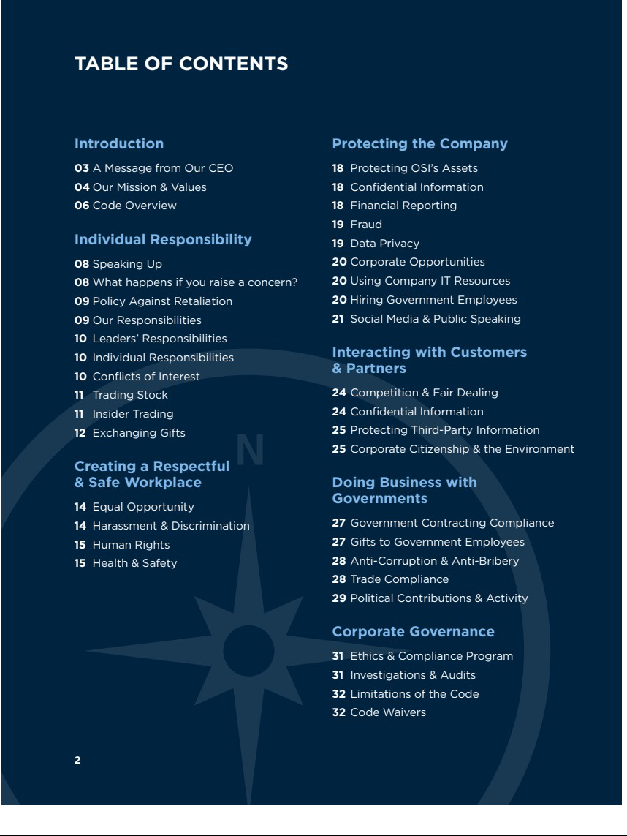



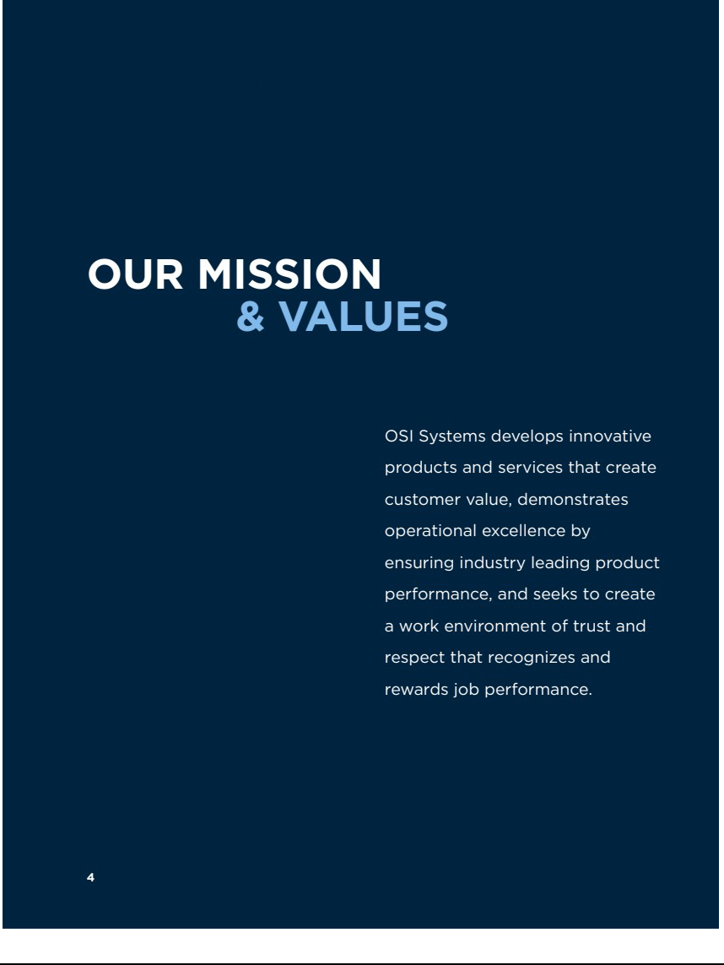

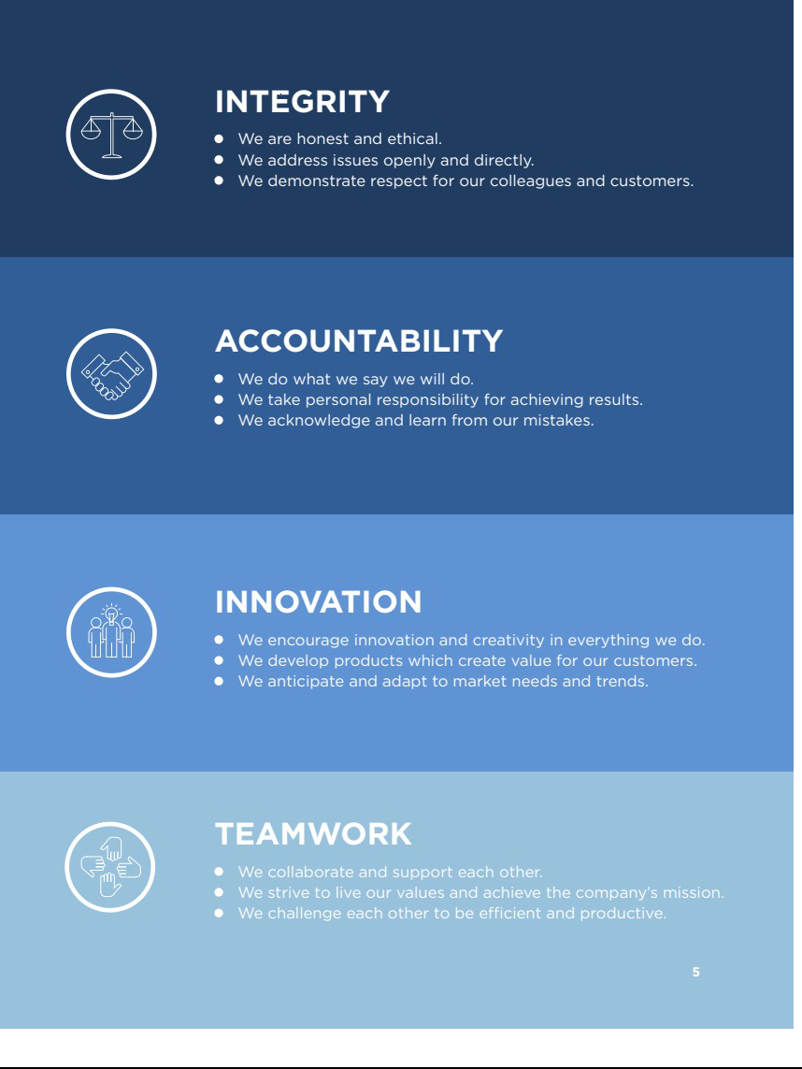



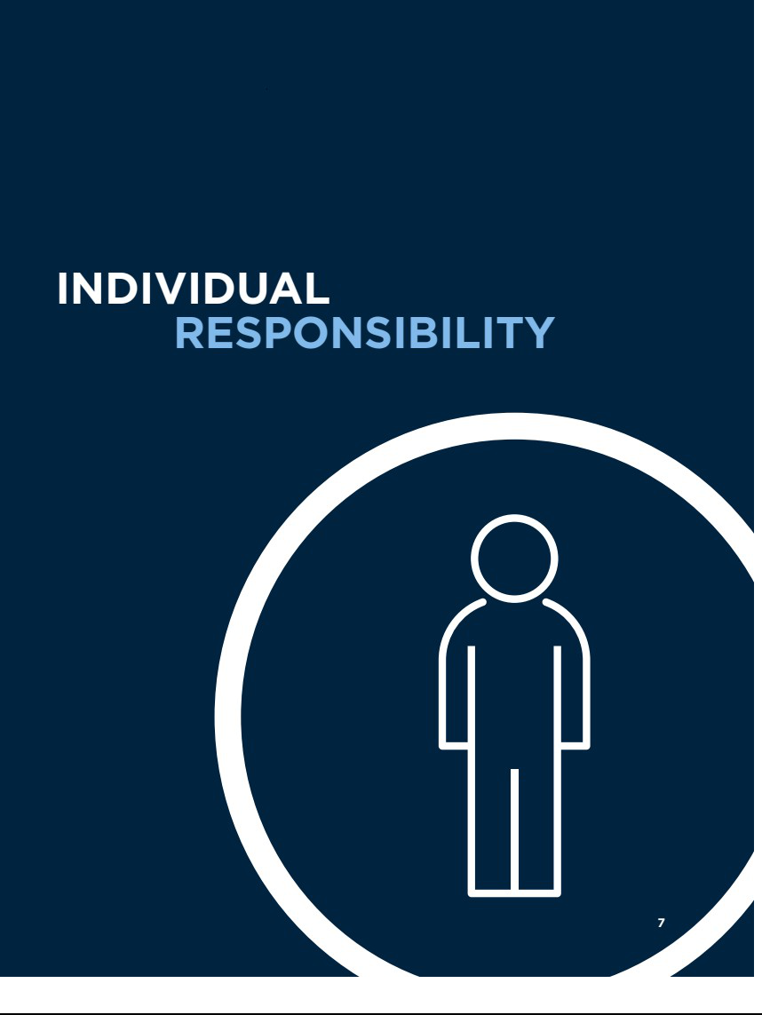

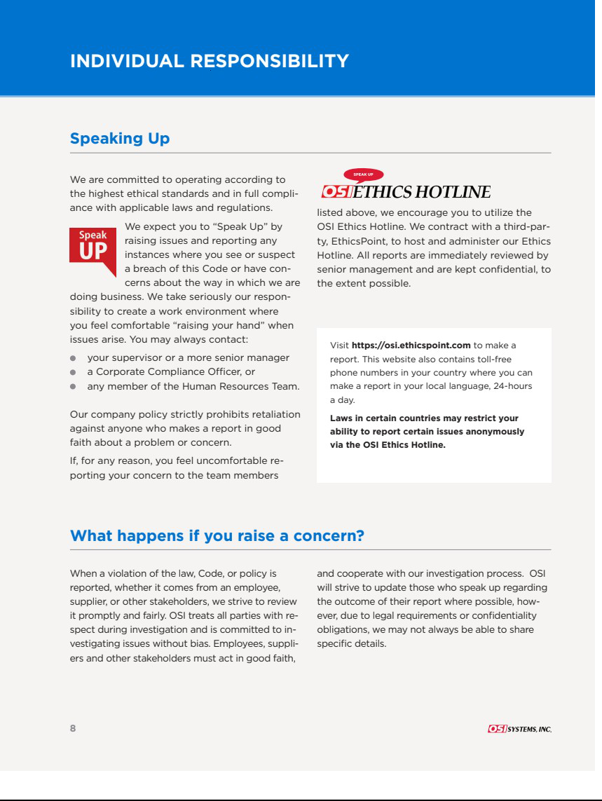

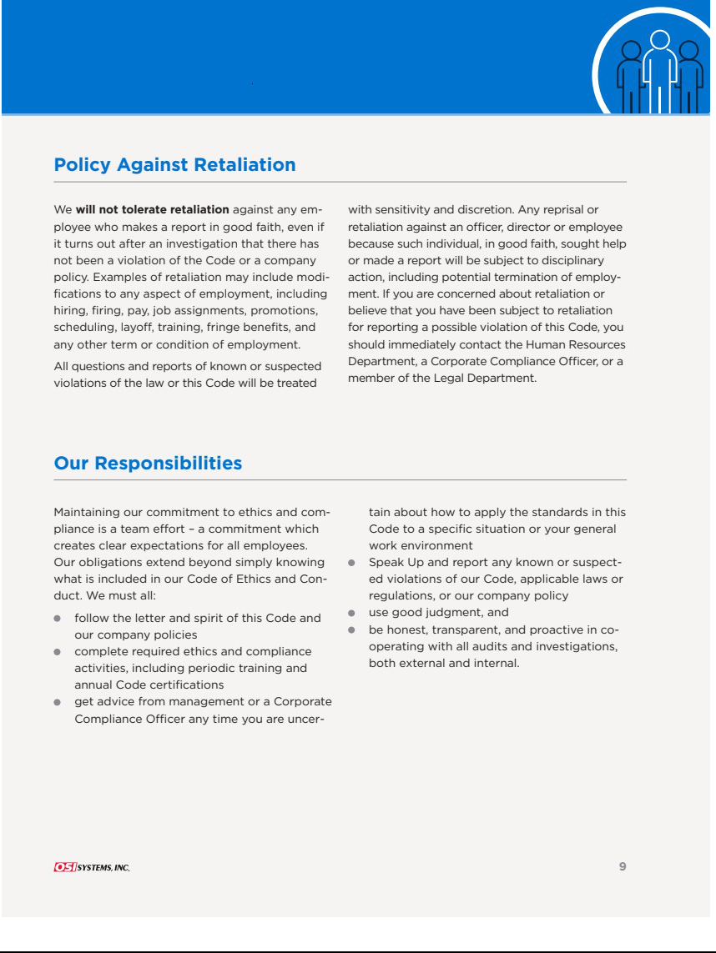

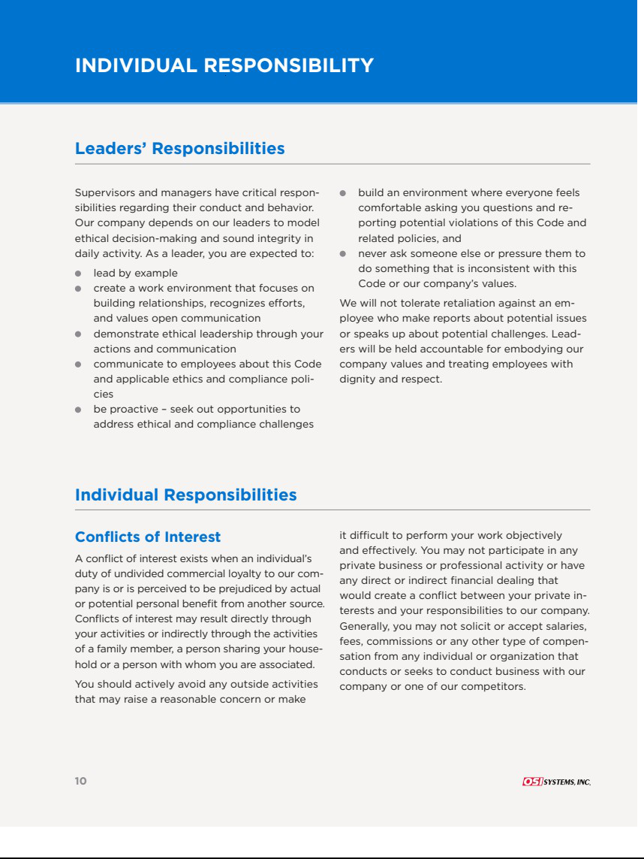

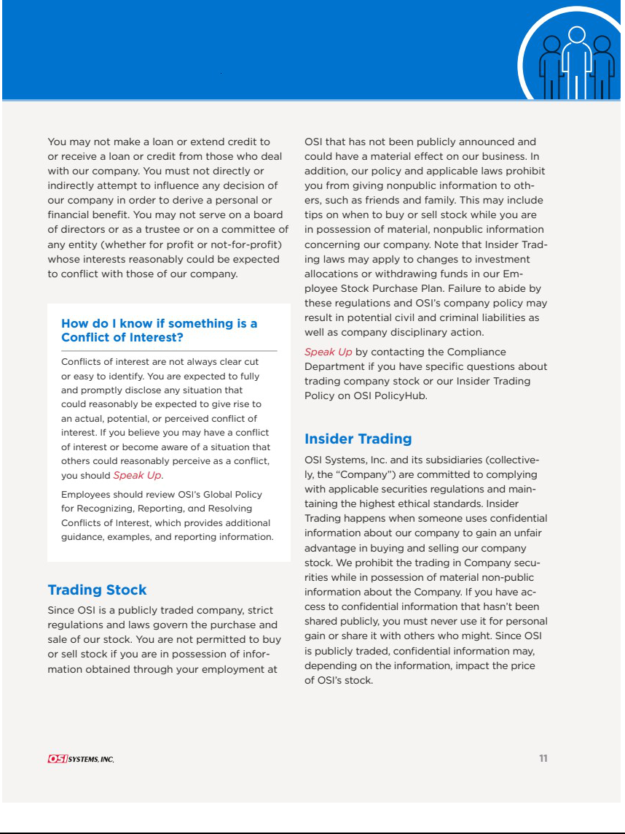













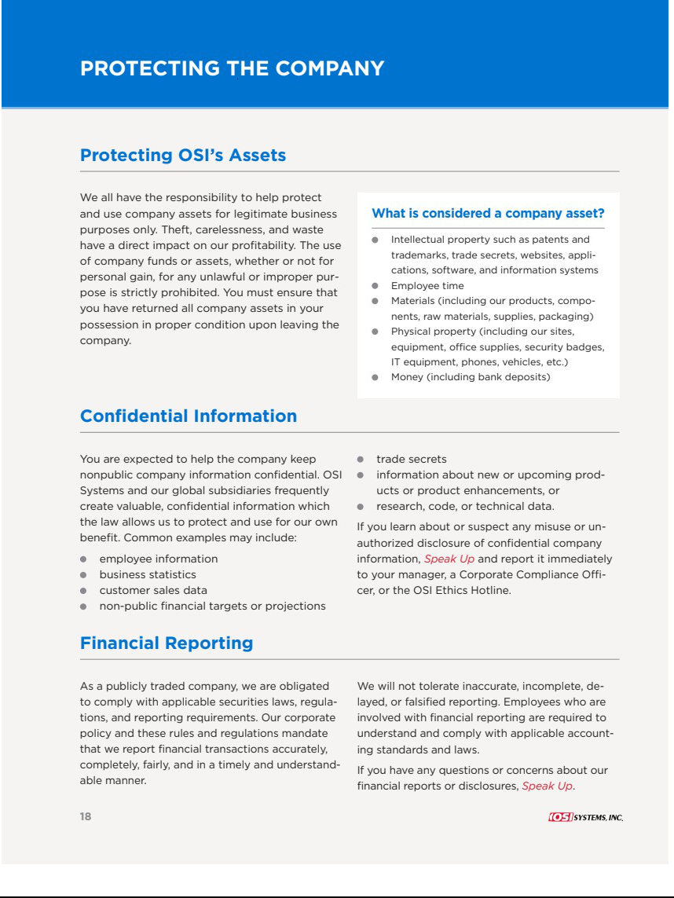

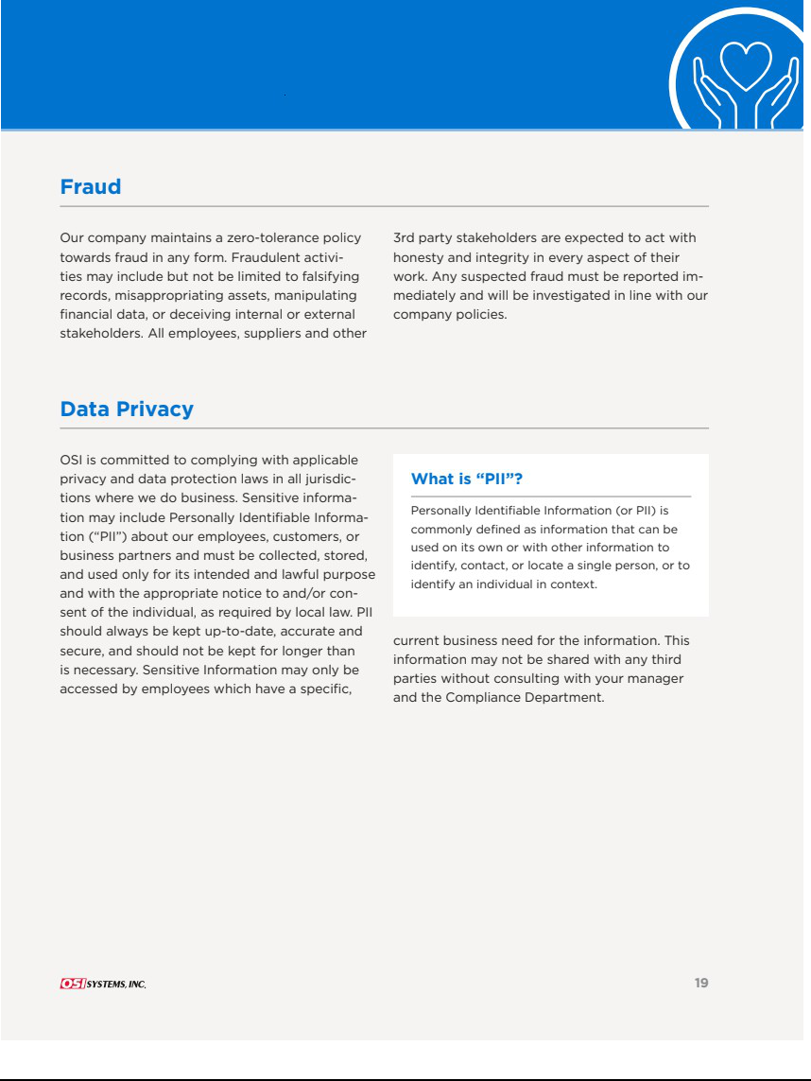

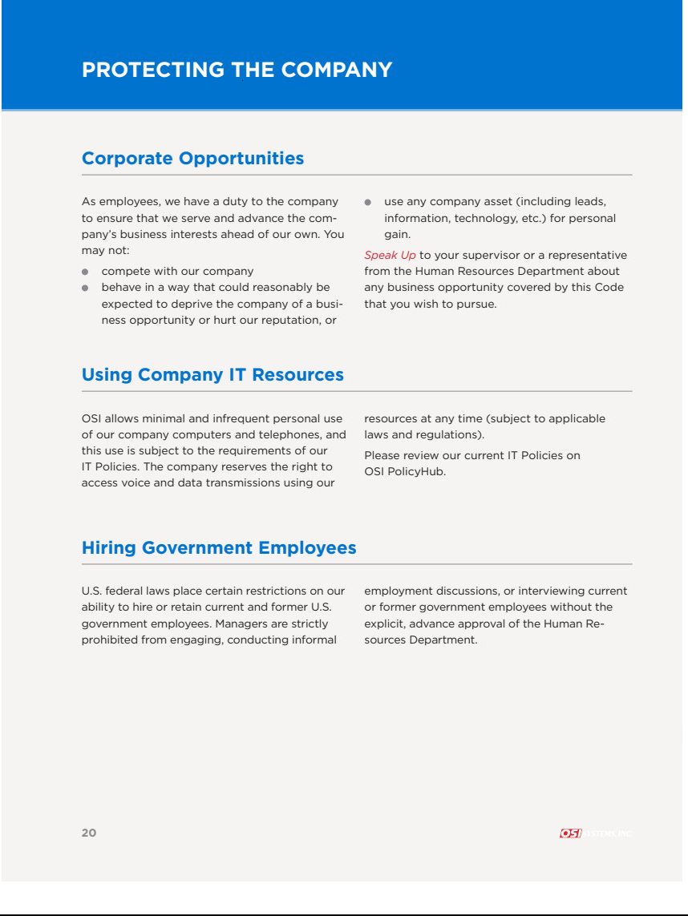









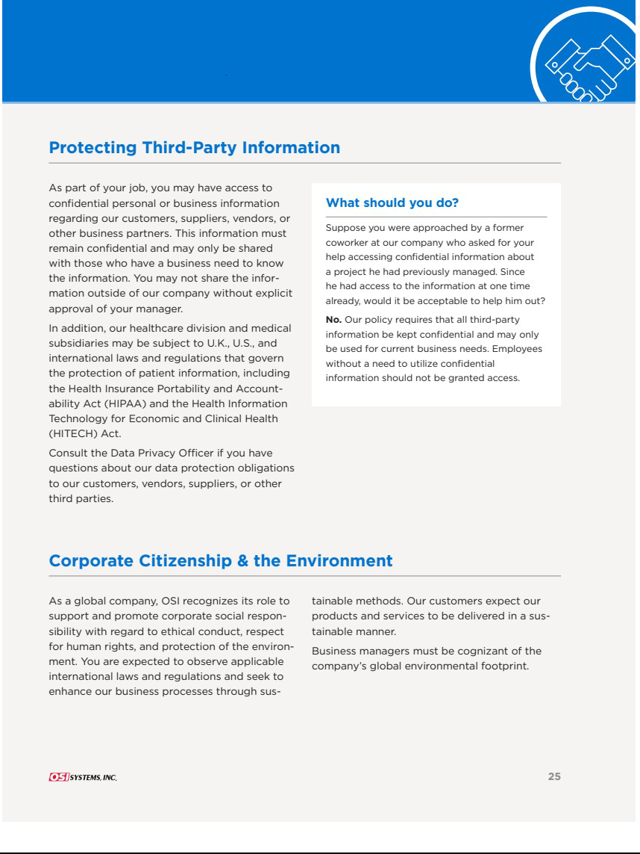



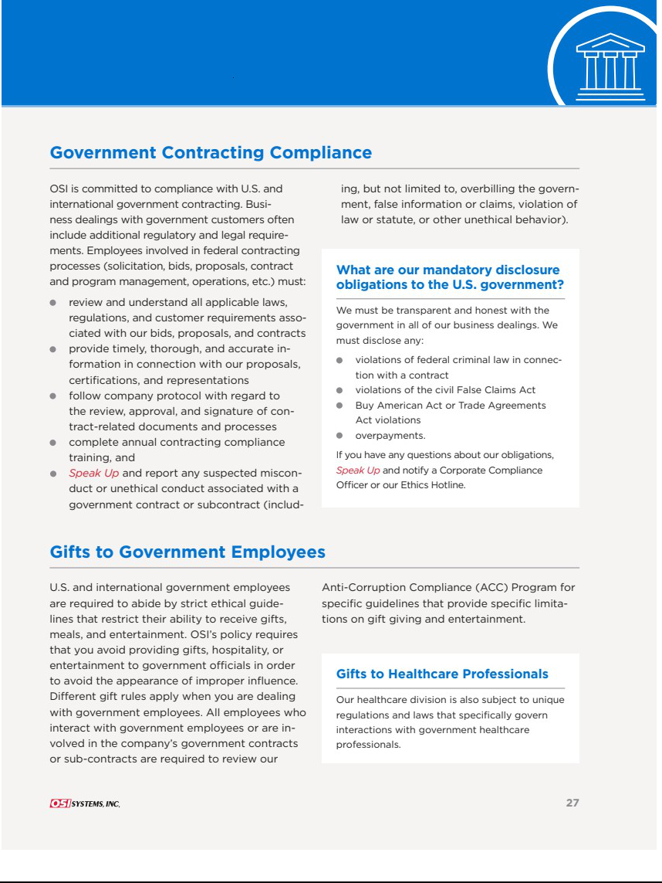

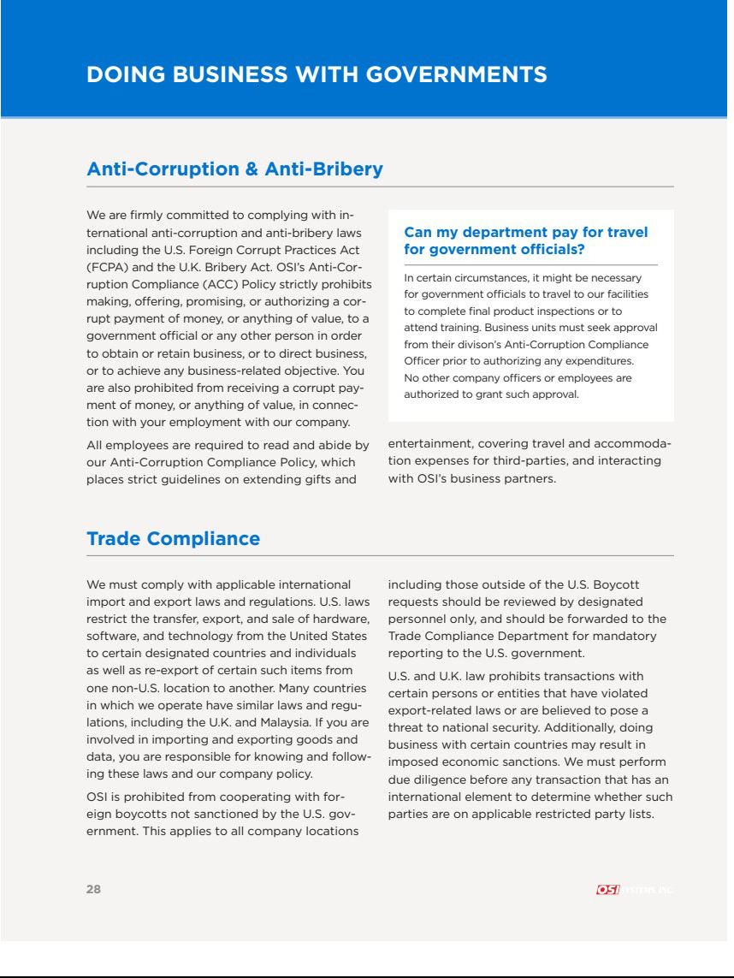





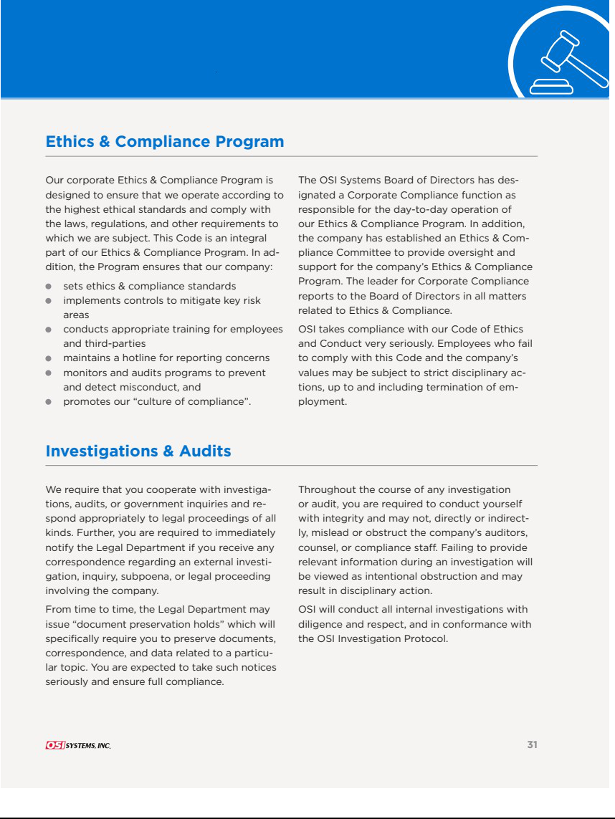

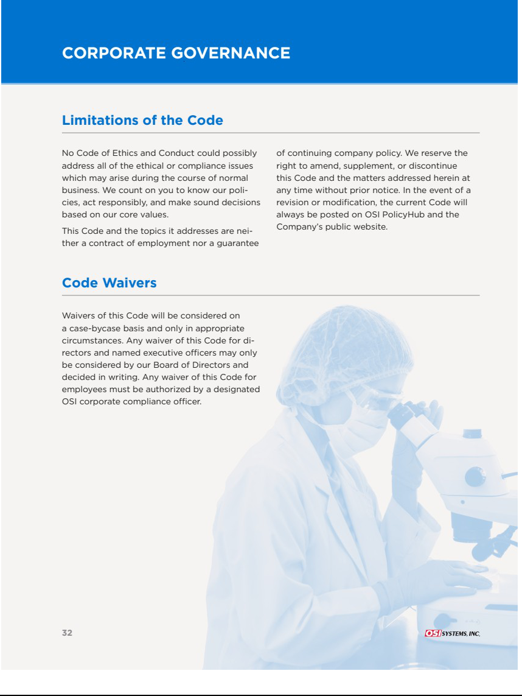

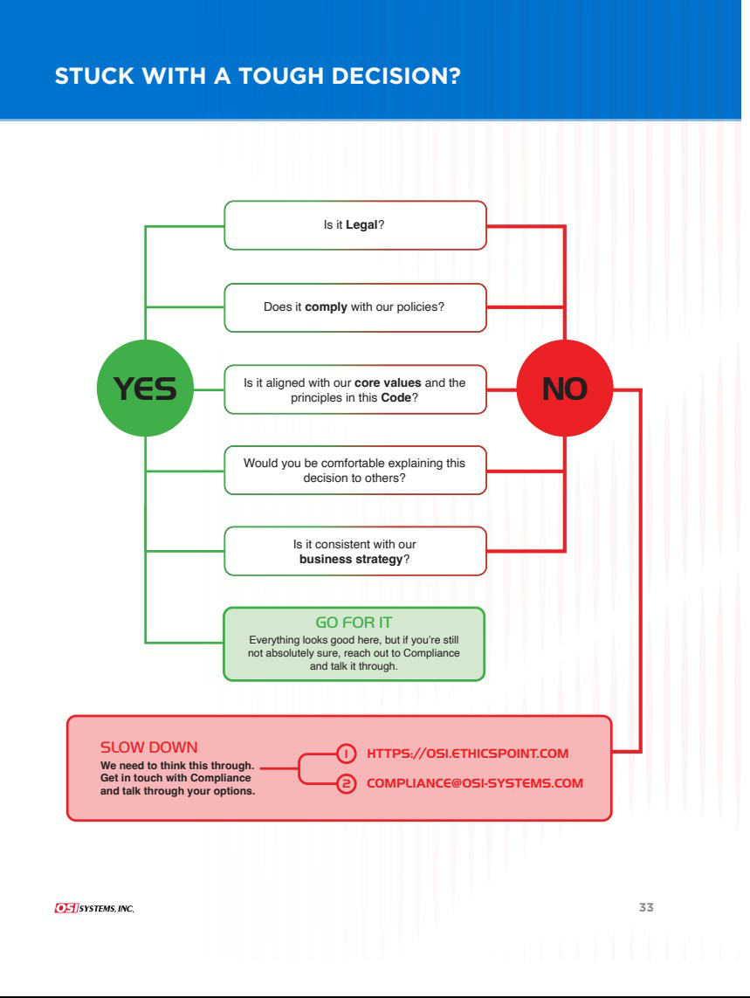







EXHIBIT 31.1

CERTIFICATION

Certification required by Rule 13a-14(a) or Rule 15d-14(a)

and under Section 302 of the Sarbanes-Oxley Act of 2002

I, Ajay Mehra, certify that:

- I have reviewed this Quarterly Report on Form 10-Q of OSI Systems, Inc.;

- Based on my knowledge, this report does not contain any untrue statement of a material fact or omit to state a material fact necessary to make the statements made, in light of the circumstances under which such statements were made, not misleading with respect to the period covered by this report;

- Based on my knowledge, the financial statements, and other financial information included in this report, fairly present in all material respects the financial condition, results of operations and cash flows of the registrant as of, and for, the periods presented in this report;

- The registrant’s other certifying officer and I are responsible for establishing and maintaining disclosure controls and procedures (as defined in Exchange Act Rules 13a-15(e) and 15d-15(e)) and internal control over financial reporting (as defined in Exchange Act Rules 13a-15(f) and
15d-15(f)) for the registrant and have:

  - Designed such disclosure controls and procedures, or caused such disclosure controls and procedures to be designed under our supervision, to ensure that material information relating to the registrant, including its consolidated subsidiaries, is made known to us by others within those entities, particularly during the period in which this report is being prepared;

  - Designed such internal control over financial reporting, or caused such internal control over financial reporting to be designed under our supervision, to provide reasonable assurance regarding the reliability of financial reporting and the preparation of financial statements for external purposes in accordance with generally accepted accounting principles;

  - Evaluated the effectiveness of the registrant’s disclosure controls and procedures and presented in this report our conclusions about the effectiveness of the disclosure controls and procedures, as of the end of the period covered by this report based on such evaluation; and

  - Disclosed in this report any change in the registrant’s internal control over financial reporting that occurred during the registrant’s most recent fiscal quarter (the registrant’s fourth fiscal quarter in the case of an annual report) that has materially affected, or is reasonably likely to materially affect, the registrant’s internal control over financial reporting; and

- The registrant’s other certifying officer and I have disclosed, based on our most recent evaluation of internal control over financial reporting, to the registrant’s auditors and the audit committee of the registrant’s board of directors (or persons performing the equivalent functions):

  - All significant deficiencies and material weaknesses in the design or operation of internal control over financial reporting which are reasonably likely to adversely affect the registrant’s ability to record, process, summarize and report financial information; and

  - Any fraud, whether or not material, that involves management or other employees who have a significant role in the registrant’s internal control over financial reporting.

Date: May 4, 2026 ​​​

/s/ Ajay Mehra
Ajay Mehra

Chief Executive Officer

(Principal Executive Officer)

EXHIBIT 31.2

CERTIFICATION

Certification required by Rule 13a-14(a) or Rule 15d-14(a)

and under Section 302 of the Sarbanes-Oxley Act of 2002

I, Alan Edrick, certify that:

- I have reviewed this Quarterly Report on Form 10-Q of OSI Systems, Inc.;

- Based on my knowledge, this report does not contain any untrue statement of a material fact or omit to state a material fact necessary to make the statements made, in light of the circumstances under which such statements were made, not misleading with respect to the period covered by this report;

- Based on my knowledge, the financial statements, and other financial information included in this report, fairly present in all material respects the financial condition, results of operations and cash flows of the registrant as of, and for, the periods presented in this report;

- The registrant’s other certifying officer and I are responsible for establishing and maintaining disclosure controls and procedures (as defined in Exchange Act Rules 13a-15(e) and 15d-15(e)) and internal control over financial reporting (as defined in Exchange Act Rules 13a-15(f) and
15d-15(f)) for the registrant and have:

  - Designed such disclosure controls and procedures, or caused such disclosure controls and procedures to be designed under our supervision, to ensure that material information relating to the registrant, including its consolidated subsidiaries, is made known to us by others within those entities, particularly during the period in which this report is being prepared;

  - Designed such internal control over financial reporting, or caused such internal control over financial reporting to be designed under our supervision, to provide reasonable assurance regarding the reliability of financial reporting and the preparation of financial statements for external purposes in accordance with generally accepted accounting principles;

  - Evaluated the effectiveness of the registrant’s disclosure controls and procedures and presented in this report our conclusions about the effectiveness of the disclosure controls and procedures, as of the end of the period covered by this report based on such evaluation; and

  - Disclosed in this report any change in the registrant’s internal control over financial reporting that occurred during the registrant’s most recent fiscal quarter (the registrant’s fourth fiscal quarter in the case of an annual report) that has materially affected, or is reasonably likely to materially affect, the registrant’s internal control over financial reporting; and

- The registrant’s other certifying officer and I have disclosed, based on our most recent evaluation of internal control over financial reporting, to the registrant’s auditors and the audit committee of the registrant’s board of directors (or persons performing the equivalent functions):

  - All significant deficiencies and material weaknesses in the design or operation of internal control over financial reporting which are reasonably likely to adversely affect the registrant’s ability to record, process, summarize and report financial information; and

  - Any fraud, whether or not material, that involves management or other employees who have a significant role in the registrant’s internal control over financial reporting.

Date: May 4, 2026 ​​​

/s/ Alan Edrick
Alan Edrick

Chief Financial Officer

(Principal Financial Officer)

EXHIBIT 32.1

CERTIFICATION OF CHIEF EXECUTIVE OFFICER PURSUANT TO 18 U.S.C. SECTION 1350

AS ADOPTED PURSUANT TO SECTION 906 OF THE SARBANES-OXLEY ACT OF 2002

In connection with the Quarterly Report of OSI Systems, Inc. (the “Company”) on Form 10-Q for the quarter ended March 31, 2026, as filed with the Securities and Exchange Commission on the date hereof (the “Report”), I, Ajay Mehra, Chief Executive Officer of the Company, certify, pursuant to 18 U.S.C. Section 1350, as adopted pursuant to Section 906 of the Sarbanes-Oxley Act of 2002, that:

- The Report fully complies with the requirements of Section 13(a) or 15(d), as applicable, of the Securities Exchange Act of 1934, as amended; and

- The information contained in the Report fairly presents, in all material respects, the financial condition and results of operations of the Company at the dates and for the periods presented in the Report.

Date: May 4, 2026 ​​​

/s/ Ajay Mehra
Ajay Mehra

Chief Executive Officer

(Principal Executive Officer)

The foregoing certification is being furnished solely pursuant to 18 U.S.C. Section 1350, is not being filed as part of the Report or as a separate disclosure document, and is not being incorporated by reference into any filing of the Company under the Securities Act of 1933, as amended, or the Securities Exchange Act of 1934, as amended (whether made before or after the date of the Report), irrespective of any general incorporation language contained in such filing. The signed original of this certification required by Section 906 of the Sarbanes-Oxley Act of 2002 has been provided to the Company and will be retained by the Company and furnished to the Securities and Exchange Commission or its staff upon request.

EXHIBIT 32.2

CERTIFICATION OF CHIEF FINANCIAL OFFICER PURSUANT TO 18 U.S.C. SECTION 1350

AS ADOPTED PURSUANT TO SECTION 906 OF THE SARBANES-OXLEY ACT OF 2002

In connection with the Quarterly Report of OSI Systems, Inc. (the “Company”) on Form 10-Q for the quarter ended March 31, 2026, as filed with the Securities and Exchange Commission on the date hereof (the “Report”), I, Alan Edrick, Chief Financial Officer of the Company, certify, pursuant to 18 U.S.C. Section 1350, as adopted pursuant to Section 906 of the Sarbanes-Oxley Act of 2002, that:

- The Report fully complies with the requirements of Section 13(a) or 15(d), as applicable, of the Securities Exchange Act of 1934, as amended; and

- The information contained in the Report fairly presents, in all material respects, the financial condition and results of operations of the Company at the dates and for the periods presented in the Report.

Date: May 4, 2026 ​​​

/s/ Alan Edrick
Alan Edrick

Chief Financial Officer

(Principal Financial Officer)

The foregoing certification is being furnished solely pursuant to 18 U.S.C. Section 1350, is not being filed as part of the Report or as a separate disclosure document, and is not being incorporated by reference into any filing of the Company under the Securities Act of 1933, as amended, or the Securities Exchange Act of 1934, as amended (whether made before or after the date of the Report), irrespective of any general incorporation language contained in such filing. The signed original of this certification required by Section 906 of the Sarbanes-Oxley Act of 2002 has been provided to the Company and will be retained by the Company and furnished to the Securities and Exchange Commission or its staff upon request.

